Notes on
Java Programming
Language

By

SAMUEL, B. O.

NOT FOR SALE

LECTURE NOTES ON
OBJECT-ORIENTED PROGRAMMING (JAVA LANGUAGE)

Table of Contents
Table of Contents 2
MODULE 1: INTRODUCTION 4
1.1 Object-oriented programming (OOP) 4
1.2 Java Programming Language 5
1.3 Application of Java 6
1.4 Features of Java 6
1.5 Components of Java 7
1.6 Why Learn Java? 7
MODULE 2: JAVA BASICS 8
2.1 Getting Started 8
2.2 Creating Your First Application 8
2.3 Running Java Program on NetBeans IDE 8
2.4 Parts of Java Program 8
2.5 Variables and Literals 9
2.6 Primitive Data Types 12
2.7 Arithmetic Operators 12
2.8 Operator Precedence 13
2.9 Type Conversion and Casting 14
MODULE 3: JAVA OBJECTS AND INPUT/OUTPUT 15
3.1 Class Strings 15
3.2 Primitive Type Variables and Reference Variables 15
3.3 The Math Class 16
3.4 Using String Method 17
3.5 User Input from Keyboard 18
3.6 Dialog Boxes for Input/Output (Java Swing Facility) 19
MODULE 4: JAVA DECISION STRUCTURE 21
4.1 The if and if-else Statements 21
4.2 Nested if Statement 24
4.3 Logical Operators 25
4.4 Java switch…case Statement 26
4.5 Conditional Operator 29
MODULE 5: LOOPS - REPETITION STRUCTURE IN JAVA 31
5.1 The Increment and Decrement Operators 31
5.2 The for loop 32
5.3 The While loop (pre-test loop) 33
5.4 The do-while loop (post-test loop) 34
5.5 Nested loop 35
5.6 The break and continue Statement 37
MODULE 6: JAVA ARRAYS 38
6.1 Introduction 38
6.2 One-dimensional Array in Java 38
6.3 Java Two Dimensional Arrays 42
6.4 Variable length Argument Lists 46
6.5 The ArrayList class 47
MODULE 7: METHODS in JAVA 49
7.1 Introduction to Methods 49
7.2 void Method 49
7.3 Passing Arguments to a Method 50
7.4 Local Variables 50
MODULE 8: INTRODUCTION TO JAVA CLASSES 51
8.1 Object and Classes 51
8.2 Designing a class 51
8.3 Constructors 53
8.4 Overloading methods 53
8.5 Unified Modelling Language Class Diagrams 53
References 55
APPENDIX - JAVA Math Methods with Output Functions 55
Tutorial Questions 58

MODULE 1: INTRODUCTION

1.1 Object-oriented programming (OOP)
Object-oriented programming (OOP) is a computer programming model that organizes software design around data, or objects, rather than functions and logic. An object can be defined as a data field that has unique attributes and behaviour. OOP focuses on the objects that developers want to manipulate rather than the logic required to manipulate them. This approach to programming is well-suited for programs that are large, complex and actively updated or maintained. This includes programs for manufacturing and design, as well as mobile applications. For example, OOP can be used for manufacturing system simulation software. The organization of an object-oriented program also makes the method beneficial to collaborative development, where projects are divided into groups. Additional benefits of OOP include code reusability, scalability and efficiency.

The first step in OOP is to collect all of the objects a programmer wants to manipulate and identify how they relate to each other -- an exercise known as data modelling. Examples of an object can range from physical entities, such as a human being who is described by properties like name and address, to small computer programs, such as widgets. Once an object is known, it is labelled with a class of objects that defines the kind of data it contains and any logic sequences that can manipulate it. Each distinct logic sequence is known as a method. Objects can communicate with well-defined interfaces called messages.

Structure of object-oriented programming
The structure, or building blocks, of object-oriented programming include the following:
- Classes: Classes are user-defined data types that act as the blueprint for individual objects, attributes and methods.
- Objects: Objects are instances of a class created with specifically defined data. Objects can correspond to real-world objects or an abstract entity. When class is defined initially, the description is the only object that is defined.
- Methods: Methods are functions that are defined inside a class that describe the behaviours of an object. Each method contained in class definitions starts with a reference to an instance object. Additionally, the subroutines contained in an object are called instance methods. Programmers use methods for reusability or keeping functionality encapsulated inside one object at a time.
- Attributes: Attributes are defined in the class template and represent the state of an object. Objects will have data stored in the attributes field. Class attributes belong to the class itself.
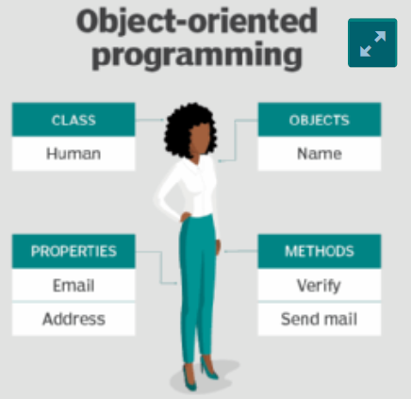

Example of the structure and naming in OOP
Principles of OOP
Object-oriented programming is based on the following principles:
- Encapsulation: This principle states that all important information is contained inside an object and only select information is exposed. The implementation and state of each object are privately held inside a defined class. Other objects do not have access to this class or the authority to make changes. They are only able to call a list of public functions or methods. This characteristic of data hiding provides greater program security and avoids unintended data corruption.
- Abstraction: Objects only reveal internal mechanisms that are relevant for the use of other objects, hiding any unnecessary implementation code. The derived class can have its functionality extended. This concept can help developers more easily make additional changes or additions over time.
- Inheritance: Classes can reuse code from other classes. Relationships and subclasses between objects can be assigned, enabling developers to reuse common logic while still maintaining a unique hierarchy. This property of OOP forces a more thorough data analysis, reduces development time and ensures
- Polymorphism: Objects are designed to share behaviours and they can take on more than one form. The program will determine which meaning or usage is necessary for each execution of that object from a parent class, reducing the need to duplicate code. A child class is then created, which extends the functionality of the parent class. Polymorphism allows different types of objects to pass through the same interface.

Examples of object-oriented programming languages
While Simula is credited as being the first object-oriented programming language, many other programming languages are used with OOP today. But some programming languages pair with OOP better than others. For example, programming languages considered pure OOP languages treat everything as objects. Other programming languages are designed primarily for OOP, but with some procedural processes included. For example, popular pure OOP languages include:
Ruby, Scala, JADE, Emerald. Significant object-oriented languages include: Java, C++, C#, Python, R, PHP, Visual Basic.NET, JavaScript, Ruby, Perl, SIMSCRIPT, Object Pascal, Objective-
C, Dart, Swift, Scala, Kotlin, Common Lisp, MATLAB, and Smalltalk.

Benefits of OOP
- Modularity: Encapsulation enables objects to be self-contained, making troubleshooting and collaborative development easier.
- Reusability: Code can be reused through inheritance, meaning a team does not have to write the same code multiple times.
- Productivity: Programmers can construct new programs quicker through the use of multiple libraries and reusable code.
- Easily upgradable and scalable: Programmers can implement system functionalities independently.
- Interface descriptions: Descriptions of external systems are simple, due to message passing techniques that are used for objects communication.
- Security: Using encapsulation and abstraction, complex code is hidden, software maintenance is easier and internet protocols are protected.
- Flexibility: Polymorphism enables a single function to adapt to the class it is placed in.

1.2 Java Programming Language
Java is one of the world's most important and widely used computer languages, and it has held this distinction for many years. Unlike some other computer languages whose influence has faded with passage of time, while Java's has grown. As of 2015, Java is one of the most popular programming languages in use, particularly for client-server web applications, with a reported 9 million developers using and working on it.
Creation of Java
Java was developed by James Ghosling, Patrick Naughton, Mike Sheridan at Sun Microsystems Inc. in 1991. It took 18 months to develop the first working version. The initial name was Oak but it was renamed to Java in 1995 as OAK was a registered trademark of another Tech company.

Evolution of Java
Java was initially launched as Java 1.0 but soon after its initial release, Java 1.1 was launched. Java 1.1 redefined event handling, new library elements were added. In Java 1.2 Swing and Collection framework was added and suspend() , resume() and stop() methods were deprecated from Thread class. No major changes were made into Java 1.3 but the next release that was Java 1.4 contained several important changes. Keyword assert, chained exceptions and channel based I/O System was introduced.

Java 1.5 was called J2SE 5, it added following major new features:
Generics, Annotations, Autoboxing and autounboxing, Enumerations, For-each Loop, Varargs, Static Import, Formatted I/O, Concurrency utilities
Next major release was Java SE 7 which included many new changes, like:
- Now String can be used to control Switch statement.
- Multi Catch Exception
- try-with-resource statement
- Binary Integer Literals
- Underscore in numeric literals, etc.
And the latest addition to the lot is, Java SE 8, it was released on March 18, 2014. Some of the major new features introduced in JAVA 8 are:
- Lambda Expressions
- New Collection Package java.util.stream to provide Stream API.
- Enhanced Security
- Nashorn Javascript Engine included
- Parallel Array Sorting

1.3 Application of Java
Java is widely used in every corner of world and of human life. It is not only used in software development but widely used in designing hardware controlling software components. There are more than 930 million JRE downloads each year and 3 billion mobile phones run java. Following are some other usage of Java:
1. Developing Desktop Applications
2. Web Applications like Linkedin.com, Snapdeal.com etc.
3. Mobile Operating System like Android
4. Embedded Systems
5. Robotics and games etc.

1.4 Features of Java
The prime reason behind creation of Java was to bring portability and security feature into a computer language. Beside these two major features, there were many other features that played an important role in moulding out the final form of this outstanding language. Those features are:
- Simple: Java is easy to learn and its syntax is quite simple, clean and easy to understand. The confusing and ambiguous concepts of C++ are either left out in Java or they have been re-implemented in a cleaner way. E.g. Pointers and Operator Overloading are not there in java but were an important part of C++.
- Object Oriented: In java, everything is object which has some data and behaviour. Java can be easily extended as it is based on ‘Object Model’.
- Robust: Java makes an effort to eliminate error prone codes by emphasizing mainly on compile time error checking and runtime checking. But the main areas which Java improved were Memory Management and mishandled Exceptions by introducing automatic Garbage Collector and Exception Handling.
- Platform Independent: Unlike other programming languages such as C, C++ etc which are compiled into platform specific machines. Java is guaranteed to be write-once, run-anywhere language. On compilation Java program is compiled into bytecode. This bytecode is platform independent and can be run on any machine, plus these bytecode formats also provide security. Any machine with Java Runtime Environment can run Java Programs.
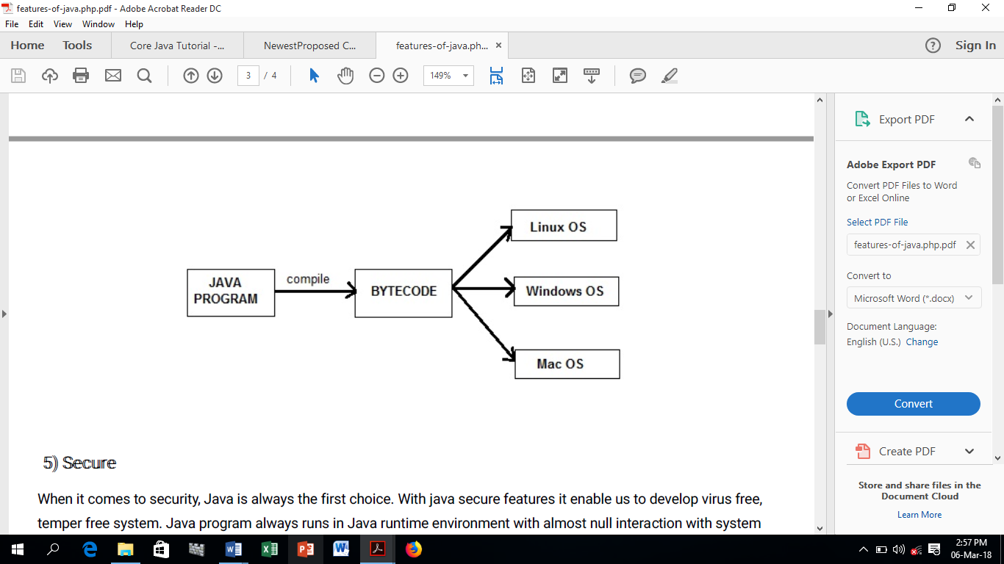

- Secure: When it comes to security, Java is always the first choice. With java secure features, it enables us to develop virus free, temper free system. Java program always runs in Java runtime environment with almost null interaction with system OS, hence it is more secure.
- Multi-Threading: Java multithreading feature makes it possible to write program that can do many tasks simultaneously. Benefit of multithreading is that it utilizes same memory and other resources to execute multiple threads at the same time, like While typing, grammatical errors are checked along.
- Architectural Neutral: Compiler generates bytecodes, which have nothing to do with a particular computer architecture, hence a Java program is easy to interpret on any machine.
- Portable: Java Byte code can be carried to any platform. No implementation dependent features. Everything related to storage is predefined. For example: size of primitive data types.
- High Performance: Java is an interpreted language, so it will never be as fast as a compiled language like C or C++. But, Java enables high performance with the use of just-in-time compiler. Well optimized Java code is nearly as fast as lower-level languages like C++ and much faster than Python, PHP, etc.

1.5 Components of Java
JVM: Java virtual Machine (JVM) is a virtual Machine that provides runtime environment to execute java byte code. The JVM doesn't understand Java typo, that's why you compile your *.java files to obtain *.class files that contain the bytecodes understandable by the JVM.
JRE: The Java Runtime Environment (JRE) provides the libraries, the Java Virtual Machine, and other components to run applets and applications written in the Java programming language. JRE does not contain tools and utilities such as compilers or debuggers for developing applets and applications.
JDK: The JDK also called Java Development Kit is a superset of the JRE, and contains everything that is in the JRE, plus tools such as the compilers and debuggers necessary for developing applets and applications.

1.6 Why Learn Java?
- Java is a platform-independent language. We can write Java code in one platform and run it in another platform
- Java is a general-purpose language with a wide range of applications. It's used for developing mobile and desktop applications, big data processing, embedded systems, and so on.
- Java is an object-oriented programming language. It helps in code reusability.

MODULE 2: JAVA BASICS

2.1 Getting Started
It is assumed that you are using a machine running Windows.

- Requirements for Creating Java Program
- A Text Editor. You can use Notepad. It is a simple editor included with the Windows Operating System. You can use a different text editor like NotePad++. Alternatively, you can you NetBeans IDE 8.x to code, run and compile Java programs. NetBeansIDE download is available online.
- In order to run Java programs, you must have the JRE (Java Runtime Environment). In order to write and run your own Java programs, you must have the JDK (Java Development Kit). The JDK includes the JRE, so you need to install JDK only. To download JDK, use the link below: http://www.oracle.com/technetwork/java/javase/downloads/index.html
It will open Java SE downloads page. Java SE stands for java standard edition. For software development you need to download JDK. Choose either 312-bit or 64-bit based on your system configuration.

2.2 Creating Your First Application
This module provides detailed instructions for compiling and running a simple "Hello World!" application. In the Java programming language, all source code is first written in plain text files ending with the .java extension. The Java compiler generates byte code. Your first application will simply display the greeting "Hello world!". To create this program, you will:
- Create a source file
- Compile the source file
- Run the program

2.3 Running Java Program on NetBeans IDE
Let us use NetBeans IDE 8.2 to run our Java programs in this course. After installing JDK 1.8 and NetBeans 8.2, to run Sample Program 1 below, follow the following instructions:

Using NetBeans IDE to Edit, Compile and Execute Java Applications
- Launch NetBeans, select File menu and then New Project submenu.
- In the New Project dialog, under Categories, select Java.
- Under Projects, select Java Application, then Next.
- In New Java Application dialog box, type project name (e.g. TASCE) in the Project Name box.
- For Project Location, browse for whatever folder you want to save the project.
- Uncheck “Create main class”.
- Click Finish. Now you have created the project.
- To create the Java application, select File, then New File.
- Under Categories, select Java, and under File Types, select Empty Java File, then click Next.
- In the Class Name box, type the class name the same way it appears in the program. Here, it is HelloWorld in the Sample Program 1 of the hand-out.
- Leave the rest as default, and select Finish.
- Type the Java application in the Sample Program 1 and save.
- To compile, select Run menu, then Build Project (or click the Hammer button).
- To run select Run, then Run Project (or click the Play button).

To print Java codes in NetBeans IDE
- Click File menu, then click Print to HTML submenu.
- In the “Print to HTML” dialog box, check Print To File box and click Browse to choose your desired location to save the codes.
- Check Show Line Numbers and Open generated HTML in browser and click OK.
- Print your code in emerging window.

2.4 Parts of Java Program
a. First Java Sample Program
Sample Program 1:
// Your First Program
class HelloWorld {
public static void main(String[] args) {
System.out.println("Hello, World!");
} //end main method
} //end class HelloWorld
Output:
Hello, World!

Parameters used in First Java Program are:
class: class keyword is used to declare classes in Java.
public: It is an access specifier or modifier. Public means this function is visible to all.
static: static is again a modifier keyword used to make a function static. To execute a static function, you do not have to create an Object of the class. The main() method here is called by JVM, without creating any object for class.
void: It is the return type, meaning this function will not return anything.
main: main() is method name. It is the most important method in a Java program. This is the method which is executed, hence all the logic must be inside the main() method. If a java class is not having a main() method, it causes compilation error.
String[] args or String args[]: This is a parameter that represents an array whose type is String and name is args. We will discuss more about array in Java Array section.
System.out.println: The code is a print statement. It prints the text Hello, World! to standard output i.e. screen. The text inside the quotation marks is called String in Java. Notice the print statement is inside the main function, which is inside the class definition.

Note:
- Every valid Java Application must have a class definition that matches the filename.
- The main method must be inside the class definition.
- The compiler executes the codes starting from the main function.

b. Comments
The first four lines of above programs are called comments. Comments are ignored by the compiler but are useful to other programmers. In Java, any line starting with // is a comment. Comments are intended for users reading the code to understand the intent and functionality of the program. It is completely ignored by the Java compiler (an application that translates Java program to Java bytecode that computer can execute).

- Multi-line Comment
The compiler ignores everything from /* to */. E.g.
/* This program demonstrates
parts of a java program
*/
- Single line Comment
In java, single-line comments begin with // and can be placed anywhere in the line.
// Display message.

c. What Happens at Runtime
After writing your Java program, then you will try to compile it. Compiler will perform some compilation operation on your program. Once it is compiled successfully, bytecode (.class file) is generated by the compiler. After compiling, you will try to run the bytecode, the following steps are performed at runtime: (1) Class loader loads the java class. It is a subsystem of JVM i.e. Java Virtual machine. (2) ByteCode verifier checks the code fragments for illegal codes that can violate access right to the object. (3) Interpreter reads the bytecode stream and then executes the instructions step by step.

2.5 Variables and Literals
a. Variable
A variable is a container that holds values that are used in a Java program. It is a location in memory (storage area) to hold data. Java is a statically-typed language. It means that all variables must be declared before they can be used. To indicate the storage area, each variable should be given a unique name (identifier). Java is a statically-typed language. It means that all variables must be declared before they can be used.

b. Create Variables in Java
To create a variable in Java, the syntax is:
data_type variable_name (identifier);
E.g. int distance;
To create variable and simultaneously assign value to it, the syntax is:
data_type variable_name (identifier) = variable_value;
E.g. int speedLimit = 80;

Here, speedLimit is a variable of int data type and we have assigned value 80 to it. The int data type suggests that the variable can only hold integers. In the example, we have assigned value to the variable during declaration. However, it's not mandatory. You can declare variables and assign variables separately. For example,
int speedLimit;
speedLimit = 80;

c. Change values of variables
The value of a variable can be changed in the program, hence the name variable. For example,
int speedLimit = 80;
... .. ...
speedLimit = 90;

Here, initially, the value of speedLimit is 80. Later, we changed it to 90. However, we cannot change the data type of a variable in Java within the same scope. That is, we can't do something like this:
int speedLimit = 80;
... .. ...
float speedLimit;

Sample Program 2:
// This program demonstrates how to use variables in a program
public class VariableExample{
public static void main(String[] args)
{
// Declare variables to hold data.
int rollno;
String name;
double marks;

// Assign values to variables.
rollno = 19;
name = "David";
marks = 89.8;

// Display the message
System.out.println("Your roll number is " + rollno);
System.out.println("Your name is " + name);
System.out.println("Your marks is " + marks);
} //end main method
} //end class VariableExample

When you compile and execute this program, the following three lines are displayed on the screen.
Your roll number is 19
Your name is Gideon
Your marks is 89.8
To explain how this happens, let’s consider following statements:
int rollno;
This line indicates the variable's name is rollno. A variable is a named storage location in the computer's memory used to hold data. Variable must be declared before they can be used. A variable declaration tells the compiler the variable's name and the type of data it will hold. In this statement int stands for integer so rollno will only be used to hold integer numbers.
Similarly, name will be used to hold text string and marks will be used to hold real numbers.
rollno = 19;
This is called an assignment statement. The equal sign is an operator that stores the value on its right into the variable named on its left. After this line executes, the rollno variable will contain the value 19.

Similarly, name will contain Gideon and marks will contain 89.8.
System.out.println("Your roll number is " + rollno);
The println() method prints the characters between quotes to the console. You can also use the + operator to concatenate the contents of a variable to a string.

d. Literals
A constant value in Java is created by using a literal representation of it. A literal can be used anywhere a value of its type is allowed. In above program, we have used following types of literals.
Literal | Type of Literal
19 | Integer literal
"Gideon" | String literal
89.8 | Double literal (real number)
"Your roll number is " | String literal
"Your name is " | String literal
"Your marks is " | String literal

e. Identifiers
- Definition and Rules
Identifiers are names of things, such as variables, constants, and methods that appear in programs. Identifiers must obey Java’s rules for identifiers. The rules for naming identifier are:
- A Java identifier consists of letters, digits, the underscore character (_), and the dollar sign ($) ; no other symbols are permitted to form an identifier.
- must begin with a letter, underscore, or the dollar sign.
- Java is case sensitive—uppercase and lowercase letters are considered different.
- Identifiers can be any length.

The following are legal identifiers in Java:
length, circleRadius, num1, $loan
Examples of Illegal Identifiers | Illegal Identifier Description
first Name | There can be no space between employee and Salary.
mail@ | The @ mark cannot be used in an identifier.
first+second | The symbol + cannot be used in an identifier.
1st | An identifier cannot begin with a digit.

- Naming Conventions
Naming conventions make programs more understandable by making them easier to read. They can also give information about the function of the identifier:
- Class names always start with an uppercase letter and follow lowercase.
- Variable names start with a lowercase letter and follow uppercase.

2.6 Primitive Data Types
In previous module, we’ve discussed that all variables must first be declared before they can be used. This involves stating the variable's type and name:
int rollno = 1;

This statement tells your program that a variable named "rollno" exists, holds numerical data, and has an initial value of "1". A variable's data type determines the values it may contain, plus the operations that may be performed on it.
There are basic data types for the storage of integers, floating-point numbers, characters, and Boolean values. These often are called primitive data types because they are in-built parts of the Java language.
- Integer Types: There are four data types you can use to store integers.
Type | Size | Values That Can Be Stored
byte | 8 bits | -128 to 127
short | 16 bits | -32,768 to 32,767
int | 32 bits | -2,147,483,648 to 2,147,483,647
long | 64 bits | -9,223,372,036,854,775,808 to 9,223,372,036,854,775,807

- Floating-point Types: Integer can store only whole numbers, another type of number that can be stored is a floating-point number. Floating-point numbers are numbers with a decimal point. In Java there are two data types that can represent floating-point numbers. They are float and double. The float data type is a single precision data type. It can store a floating-point number with 7 digits of accuracy. The double data type is a double precision data type. It can store a floating-point number with 15 digits of accuracy. A float variable occupies 4 bytes of memory, whereas a double variable uses 8 bytes.
- Character type: The char type is used for individual characters, such as letters, numbers, punctuation, and other symbols.
- Booleans: Boolean data type holds either true or false in Java.

2.7 Arithmetic Operators
Java has five arithmetic operators:
+ (addition), - (subtraction), * (multiplication), / (division), % (mod or remainder)
Arithmetic Operators | Expression | Result
+ | 2 + 3 | 5
- | 48 - 10 | 38
* | 3 * 5 | 15
/ | 14 / 3 | 4
% | 11 % 4 | 3

Sample Program 3:
//This program finds area of circle using arithmetic Operators
import java.util.Scanner;
public class AreaOfCircle {
public static void main(String args[]) {
// Create a Scanner object to read input.
Scanner s= new Scanner(System.in);
System.out.println("Enter the radius:");

// Get the input from the keyboard
double r= s.nextDouble();
double area=(22*r*r)/7;
System.out.println("Area of Circle is: " + area + " cm. sq");
}
}

OR
//This program finds area of circle using arithmetic Operators
import java.util.Scanner;
public class AreaOfCircle2{
public static void main(String args[]) {
double r, area;
// Create a Scanner object to read input.
Scanner console = new Scanner(System.in);

// Get the input from the keyboard
System.out.println("Enter the radius:");
r = console.nextFloat();
area =(22*r*r)/7;
System.out.println("Area of Circle is: " + area + " cm. sq");
}
}

2.8 Operator Precedence
Consider the following statement:
X = 5 + 30 * 10

x will store 305. In this equation, the numbers 30 and 10 are multiplied first, and the number 5 is added to their product. Multiplication, division and modulus have higher order than addition and subtraction, which means that they’re performed first. If two operators sharing an operand have the same precedence, they work according to their associativity. Associativity is either left to right or right to left. Associativity of - (unary negation) is Right to left and * / + - is Left to right. Some expressions and their values are:

Expression | Value
6 + 2 * 3 | 12
8 / 2 - 3 | 1
8 + 10 * 2 - 4 | 24
4 + 11 % 2 - 1 | 4
6 - 3 * 3 + 7 - 1 | 3

Combined Assignment Operator
Operator | Example | Meaning
+= | x += 5 | x = x +5
-= | x -= 5 | x = x - 5
*= | x *= 2 | x = x * 2
%= | x %= 3 | x = x % 3
/= | x /= 4 | x = x / 4

Increment and Decrement Operators
These operators are unary operators because they operate on a single operand. Increment operator ++ is used to add 1 to variable's value, and decrement operator -- is used to subtract 1 from its value. Increment and decrement operators each have two forms: pre and post.
The syntax of the increment operator is:
Pre-increment: ++variable
Post-increment: variable++
The syntax of the decrement operator is:
Pre-decrement: --variable
Post-decrement: variable--
Consider the following code:
int x, y, z;
x = 24;
y = x++; // y is given x’s value(24)before it is incremented and x is then incremented to 25
z = ++x; // x is incremented to 25, and z is given x’s value

2.9 Type Conversion and Casting
Java is a strongly typed language. This means that before a value is assigned to a variable, Java checks the data types of the variable and the value being assigned to it to determine whether they are compatible.
For example, look at the following statements:
int x;
double y = 8.5;
x = y; // error!! float value cannot be assigned to int variable

double a;
int b = 8;
a = b; // Ok. int value can be assigned to float variable

int i;
short j = 10;
i = j; // Ok. short value can be assigned to int variable

Java’s Automatic Conversions
When one type of data is assigned to another type of variable, an automatic type conversion will take place if the following two conditions are met:
- The two types are compatible.
- The destination type is larger than the source type.

Casting Incompatible Types
To create a conversion between two incompatible types, you must use a cast. A cast is simply an explicit type conversion. It has this general form:
(target-type) value

int x;
double y = 8.5;
x = (int)y; // Ok. The cast operator is applied to the value of y.
//Ihe operator returns 8, which is stored in variable x.

Mixed Expression
When evaluating an operator in a mixed expression, if the operator has the same types of operands, the operator is evaluated according to the type of the operand. If the operator has different types of operands, the result is a larger type number.
Consider the following code:
int x, y;
double a;
x = 3;
y = 2;
a = 5.1;
System.out.println(x / y + a);
output:
6.6

Named Constants
In some programs, we need a memory location whose content should not be changed during program execution. To declare such named constant, use the final keyword before the variable declaration and include an initial value for that variable, as in the following:
final float PI = 3.141592;
final boolean DEBUG = false;
final double INTEREST_RATE = 0.075;
It is a common coding convention to choose all uppercase identifiers for final variables.

MODULE 3: JAVA OBJECTS AND INPUT/OUTPUT

3.1 Class Strings
Strings are a sequence of characters. In the Java programming language, string is an object rather than a primitive data type. The Java platform provides the String class to create and manipulate strings.

Creating Strings
The most direct way to create a string is to write:
String greeting = "Hello world";

In this case, "Hello world" is a string literal—a series of characters in your code that is enclosed in double quotes. Whenever it encounters a string literal in your code, the compiler creates a String object with its value—in this case, Hello world. Every character in a string has a specific position in the string. The position of the first character is 0, the position of the second character is 1, and so on. The length of a string is the number of characters in it.
String | Hello World
Character in the string | H | e | l | l | o |  | W | o | r | l | d
Position of the character in the string | 0 | 1 | 2 | 3 | 4 | 5 | 6 | 7 | 8 | 9 | 10

String Arithmetic
The + operator can concatenate two or more strings. In previous module, you have seen statement that look something like this:
String name = "Gideon";
System.out.println("Your name is " + name);
These two lines result in the display of the following text output:

Your name is Gideon

The + operator combines strings, other objects, and variables to form a single string. In the preceding example, the literal "Your Name is " is concatenated to the value of the String object name. If any part of a concatenation operation is a String or a string literal, all elements of the operation will be treated as if they were strings:
System.out.println("Your roll number is " + 19);

This produces the output Your roll number is 19, as if the integer literals 19 is string.

3.2 Primitive Type Variables and Reference Variables
In previous module, you learned how to declare a primitive type variable, and string variable.
Consider the following statements:
int rollno;

This notifies the compiler that you will use rollno to refer to data whose type is int. This declaration also reserves the proper amount of memory for the variable.
rollno = 19;

This statement tells the compiler to store 19 to memory space.
Following figure illustrate that a primitive type variable holds the data with which it is associated.
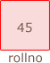

Consider the following statements:
string msg;

This statement allocates memory space for the variable msg. However, unlike the variable rollno, the variable str cannot directly store data in its memory space. You must assign a string object to msg before you use it in your code.
For example:
msg = "Programming is fun";

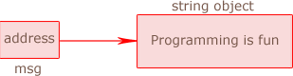
The statement stores the string object "Programming is fun" in this memory space, and then stores the starting address of string in the memory space of msg. This msg is called reference variable.

3.3 The Math Class
The Java API provides a class named Math, which contains number of static methods that compute various common mathematical functions. The Java Math class provides more advanced mathematical calculations than what the basic Java math operators provide. The Math class contains methods for finding the maximum or minimum of two values, rounding values, logarithmic functions, square root, and trigonometric functions (sin, cos, tan etc.). The Math is located in the java.lang package, and not in the java.math package. Thus, the fully qualified class name of the Math class is java.lang.Math. A static method can be called using the name of the class containing the method.

- The pow() Method
The class Math contains a method pow, which is used to calculate x raised to power y (x^{y}) in a program. Here is an example of how the pow method is used:
result = Math.pow(2, 3);

Math.pow(2,3) computes 8.0. This statement is equivalent to the following algebraic statement
result = 2³

- The sqrt() Method
The Math.sqrt method accepts a value as its argument and returns the square root of the value. Here is an example of how the method is used:
result = Math.sqrt(16.0);

For more Java Math method, see Appendix.

Sample Program 4:
In this example, the value 16.0 is passed as an argument to the sqrt method. The method then returns the square root of 16.0, which is assigned to the result variable.

// This program demonstrate Class Math methods.
public class MathMethodsExample{
public static void main(String[] args){
// To hold data.
double x, y, result;

x = 16;
y = 2.0;

// Get the power.
result = Math.pow(x, y);

// Display result.
System.out.println(result);

// Get square root.
result = Math.sqrt(x);
// Display result.
System.out.println(result);
}
}
Output:
256.0
4.0

3.4 Using String Method
Like other Java inbuilt classes, String class also provides numerous predefined methods. A method is a collection of instructions. When a method executes, it accomplishes something.
The general expression to use a predefined method on a Reference variable is:
ReferenceVariable.MethodName(parameters)

The following statement calculates the length of string by using predefined method length().
String message = "The Java Tutorials";
int n = message.length();

In the statement, message is a reference variable. Value of the expression message.length() returns 18 which is then stored in variable n.

Sample Program 5:
//This program demonstrates length String methods
public class StringLengthExample{
public static void main(String[] args){
String message; // To hold a string
int n; // To hold length of String

message = "The Java Tutorials";
n = message.length();
System.out.println("The length of message: " + n);
}
}
Output:
The length of message: 18

The String class is immutable so that once it is created, a String object cannot be changed. The String class has a number of methods, some of which will be discussed below, that appear to modify strings. Since strings are immutable, what these methods really do is create and return a new string that contains the result of the operation.
String toLowerCase() | Returns the string that is the same as this string, except that all uppercase letters of this string are replaced with their equivalent lowercase letters Example: message.toLowerCase() returns "the java tutorials"
String toUpperCase() | Returns the string that is the same as this string, except that all lowercase letters of this string are replaced with their equivalent uppercase letters Example: message.toUpperCase() returns "THE JAVA TUTORIALS"
String concat(String str) | Returns the string that is this string concatenated with str Example: The expression message.concat(" For Beginners") returns the string "The Java Tutorials For Beginners".
String substring (int beginIndex) | Returns the string which is a substring of this string beginning at beginIndex until the end of the string. Example: message.substring(4) returns the string "Java Tutorials"
String substring(int beginIndex, int endIndex) | Returns the string which is a substring of this string beginning at beginIndex until endIndex – 1  Example: message.substring(4,18) returns the string "Java Tutorials"

Sample Program 6:
//This program demonstrates various String methods.
public class StringMethodsExample{
public static void main(String[] args) {
String message;

message = "The Java Tutorials";
System.out.println(message.toLowerCase());
System.out.println(message.toUpperCase());
System.out.println(message.concat(" For Beginners"));
System.out.println(message.substring(4));
System.out.println(message.substring(4, 8));
}
}
Output:
the java tutorials
THE JAVA TUTORIALS
The Java Tutorials For Beginners
Java Tutorials
Java

3.5 User Input from Keyboard
Accepting keyboard input in Java is done using a Scanner object. Consider the following statement:
Scanner console = new Scanner(System.in)

This statement declares a reference variable named console. The Scanner object is associated with standard input device (System.in). To get input from keyboard, you can call methods of Scanner class. For example, in the following statement nextInt() method of Scanner takes an integer and returns to variable x:
int x = console.nextInt();
Note: Any letter or word can be used instead of “console”. E.g. s, s1, joy, input etc.

Sample Program 7:
import java.util.Scanner; // Needed for Scanner class
// This program demonstrates keyboard input
public class RectangleArea{
public static void main(String[] args) {
int length; // To hold rectangle's length.
int width; // To hold rectangle's width.
int area; // To hold rectangle's area

// Create a Scanner object to read input.
Scanner segun = new Scanner(System.in);

// Get length from the user.
System.out.print("Enter length ");
length = segun.nextInt();

// Get width from the user.
System.out.print("Enter width ");
width = segun.nextInt();

// Calculate area.
area = length * width;

// Display area.
System.out.println("The area of rectangle is " + area + " " + "cm. sq.");
}
}
Output:
Enter length 5
Enter width 8
The area of rectangle is 40 cm. sq.

Some other useful methods of Scanner class
Method | Returns
int nextInt() | Returns the next token as an int.
float nextFloat() | Returns the next token as a float.
double nextDouble() | Returns the next token as a long.
String next() | Finds and returns the next complete token as a string ended by a blank.
String nextLine() | Returns the rest of the current line, excluding any line separator at the end.

Sample Program 8:
import java.util.Scanner;
//This program demonstrates various Scanner methods
public class ReadEmployee{
public static void main(String[] args) {
String name; // To hold the employee's name
int age; // To hold the employee's age
char gender; // To hold the employee's gender
double salary; // To hold the employee's salary

// Create a Scanner object to read input.
Scanner x1 = new Scanner(System.in);

// Get the employee's name
System.out.print("Enter name: ");
name = x1.nextLine();

// Get the employee's age
System.out.print("Enter age: ");
age = x1.nextInt();

// Get the employee's gender
System.out.print("Enter gender: ");
gender = x1.next().charAt(0);

// Get the employee's salary
System.out.print("Enter salary: ");
salary = x1.nextDouble();

// Display the information
System.out.println("Name: " + name + " Age: " + age + " Gender: "
+ gender + " Salary: " + salary);
}
}
Output:
Enter name: Alex Jaguna
Enter age: 34
Enter gender: M
Enter salary: 8000
Name: Alex Joseph Age: 24 Gender: M Salary: 8000.0

3.6 Dialog Boxes for Input/Output (Java Swing Facility)
A dialog box is a small graphical window that displays a message to the user or requests input. Two of the dialog boxes are:
- Message Dialog - a dialog box that displays a message.
- Input Dialog - a dialog box that prompts the user for input.

The ‘javax.swing.JOptionPane’ class offers dialog box methods. This is needed for dialog box. The following statement must be before the program’s class header:
import javax.swing.JOptionPane;

Syntax:
JOptionPane.showMessageDialog (null, <message> );

The showMessageDialog method has four parameters to be passed into it: (1) null, (2) user’s output, (3) title of the message dialog and (4) the type of icon to be attached to the message box whether error, information or other. More emphasis is laid on the last three parameters. Each of this parameter is separated by commas. The last parameter is the icon to be attached to the message box. If we use JOptionPane.PLAIN_MESSAGE, it means that no icon will show. We can also use JOptionPane.INFORMATION_MESSAGE or JOptionPane.ERROR_MESSAGE. Note the use of underscore.

Sample Program 9:
//This program demonstrates showMessageDialog.
import javax.swing.JOptionPane; // Needed for Dialog Box
public class MessageDialogExample{
public static void main(String[] args) {
JOptionPane.showMessageDialog(null, "Welcome");
}
}

Output:
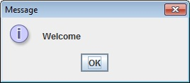

- Input Dialog
Syntax:
<String variable> = JOptionPane.showInputDialog(<message> )

- Reading String Input
Sample Program 10:
//This program demonstrates showInputDialog.
import javax.swing.JOptionPane; // Needed for Dialog Box
public class InputDialogExample{
public static void main(String[] args) {
String name;

// Get the user's name.
name = JOptionPane.showInputDialog("What is your name? ");

// Display message
JOptionPane.showMessageDialog(null, "Hello " + name);
}
}
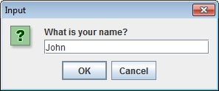
Program Output
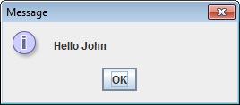

- Reading Number Input
The JOptionPane’s showInputDialog method always returns the user's input as a String. String containing a number, such as "15", can be converted to a numeric data type.

- The Parse Methods
Each of the numeric wrapper classes (discussed later), has a parse method that converts (parse) a string to a number.
int amount = Integer.parseInt("259"); // Store 259 in amount variable.
double payment = Double.parseDouble("794.6"); // Store 794.6 in payment variable.

Sample Program 11:
import javax.swing.JOptionPane; // Needed for Dialog Box
public class Cylinder{
public static void main(String[] args) {
float r = Float.parseFloat(JOptionPane.showInputDialog("Enter the radius"));
float h = Float.parseFloat(JOptionPane.showInputDialog("Enter the height"));
double volume = Math.PI*Math.pow(r,2)*h; // or double area = Math.PI*r*r*h;
double perimeter = 2.0*Math.PI*r;
// Display the results
JOptionPane.showMessageDialog(null, "Volume of the cone is " + volume + " cm. cube" + "\n Perimeter of the base is " + perimeter + " cm");
}
}
Output:
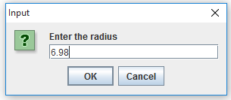
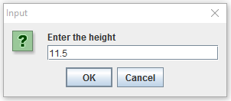
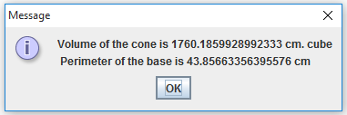

Exercise 1: Write a program that inputs from the user the radius and height of a conical object and then prints the circumference of the base and volume of the cylinder in cm cube using the predefined constant Math.PI.

Exercise 2: If a triangle has side lengths a,b,c, then the formula for the area of the triangle. Write a program that asks the user to enter three sides of triangle.
Note: Area = 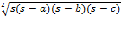 where s =
Exercise 3: Write a program that asks for a temperature in Celsius and prints out the temperature in Fahrenheit. Use InputBox for input and OutputBox for output. The formula to convert Celsius to the equivalent Fahrenheit is: fahrenheit = 1.8 x celsius + 32

MODULE 4: JAVA DECISION STRUCTURE

4.1 The if and if-else Statements
a. if Statement
To write useful programs, we almost always need to check conditions and change the behaviour of the program accordingly. Conditional statements give us this ability. The syntax of if conditional statement is:
if (testExpression)
{
// statements
}

The if statement evaluates the test expression inside parenthesis. If test expression is evaluated to true, statements inside the body of if is executed. If test expression is evaluated to false, statements inside the body of if is skipped.
The simplest form in Java is the if statement:
if (x > 0)
{
System.out.println("x is positive");
}

The expression in parentheses is called the condition. If it is true, then the statements in brackets get executed. If the condition is not true, nothing happens.
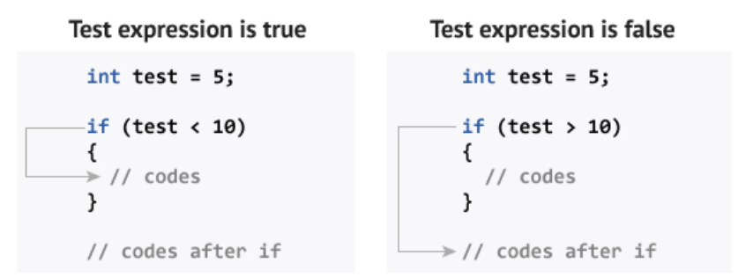
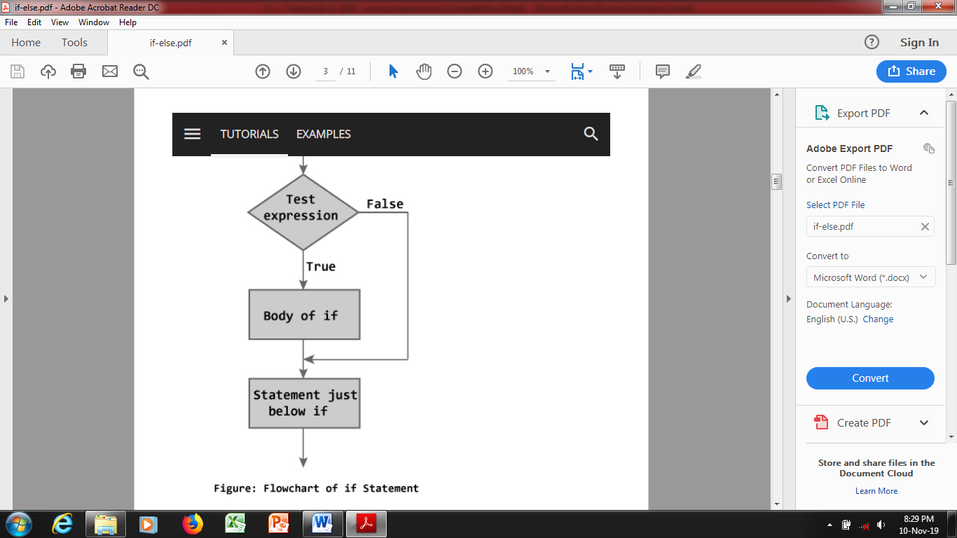
The flowchart below describes how if statement works:

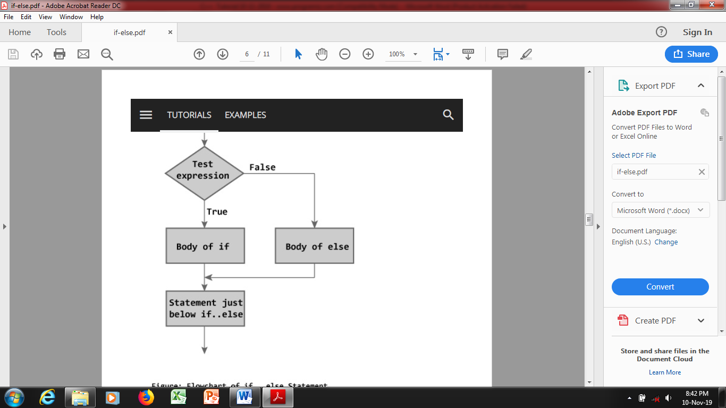
b. if-else statement
Flowchart of if…else statement

A second form of conditional execution is alternative
execution, in which there are two possibilities, and
the condition determines which one gets executed.
The syntax is:
if (condition)
{
statement to execute when the condition is true;
}
else
{
statement to execute when the condition is false;
}

The if else executes the codes inside the body of if statement if the test expression is true and skips the codes inside the body of else. If the test expression is false, it executes the codes inside the body of else statement and skips the codes inside the body of if.
Sample Program 12:
// This program reads two numbers from keyboard and determine the maximum number.
import java.util.Scanner; // Needed for the Scanner class
public class Maximum{
public static void main(String[] args){
int number1, number2; // store two numbers
int max; // store maximum of two numbers

// Create a Scanner object to read input.
Scanner y = new Scanner(System.in);

// Get two numbers from the user.
System.out.print("Enter an integer: ");
number1 = y.nextInt();
System.out.print("Enter another integer: ");
number2 = y.nextInt();

// Determine maximum of two.
if (number1 > number2)
{
max = number1;
}
else
{
max = number2;
}

System.out.println("Maximum number is " + max);
}
}
Output:
Enter an integer: 5
Enter another integer: 16
Maximum number is 16

Sample Program 13:
Write a program determine the grade based on score obtained by student. Score is read by keyboard. Grade is determined as stated in the table below:
Score | Grade
90-100 | A
80-89 | B
70-79 | C
50-69 | D
0-59 | F

// This program determine grade for a test score.
import java.util.Scanner; // Needed for the Scanner class
public class GradeComputation{
public static void main(String[] args){
int score; // To hold a test score
char grade; // To hold a letter grade

// Create a Scanner object to read input.
Scanner ade = new Scanner(System.in);

// Get the test score.
System.out.print("Enter your numeric test score : ");
score = ade.nextInt();

// Calculate the grade.
if (score >= 90)
{
grade = 'A';
}
else if (score >= 80)
{
grade = 'B';
}
else if (score >= 70)
{
grade = 'C';
}
else if (score >= 50)
{
grade = 'D';
}
else
{
grade = 'F';
}

// Display the grade.
System.out.println("Your grade is " + grade);
}
}
Output 1:
Enter your numeric test score : 56
Your grade is D
Output 2:
Enter your numeric test score : 89
Your grade is B

4.2 Nested if Statement
In addition to chaining, you can also nest one condition within another. Example is:
if (x == 0)
{
System.out.println("x is zero");
}
else
{
if (x > 0)
{
System.out.println("x is positive");
}
else
{
System.out.println("x is negative");
}
}

Sample Program 14:
Following program determines whether the year is a leap year or not. Leap Years are any year that can be evenly divided by 4. A year that is evenly divisible by 100 is a leap year only if it is also evenly divisible by 400.
//This program demonstrates a nested if statement
import java.util.Scanner; //Needed for Scanner object
public class Leapyear{ //starts Leapyear class
public static void main(String[] args) { //starts main method
int year; // holds a year

// Create a Scanner object for keyboard input.
Scanner my = new Scanner(System.in);
// Get the year.
System.out.print("Enter a year : ");
year = my.nextInt();

// Determine whether the year is leap year.
if (year % 4 == 0)

{
if (year % 100 == 0)
{
if (year % 400 == 0)
{
System.out.println("A leap year");
}
else
{
System.out.println("Not a leap year");
}
}
else
{
System.out.println("A leap year");
}
}
else
{
System.out.println("Not a leap year");
}
} //ends main method
} /ends Leapyear class

Output 1:
Enter a year : 1992
A leap year
Output 2:
Enter a year : 2000
A leap year
Output 3
Enter a year : 1900
Not a leap year
Output 4
Enter a year : 2015
Not a leap year

4.3 Logical Operators
There are three logical operators in Java: AND, OR and NOT, which are denoted by the symbols &&, || and !. Logical operators can simplify nested conditional statements.

Sample Program 15: Program to determine the greatest of three numbers.
//This program demonstrates the logical && operator
import java.util.Scanner; // Needed for the Scanner class
public class Maximum{
public static void main(String[] args) {
int num1, num2, num3; // holds three integers
int max; // holds maximum value

// Create a Scanner object for keyboard input.
Scanner p5 = new Scanner(System.in);

// Get theee integers.
System.out.print("Enter three integers : ");
num1 = p5.nextInt();
num2 = p5.nextInt();
num3 = p5.nextInt();

// Determine the maximum number
if ((num1 > num2) && (num1 > num3))
{
max = num1;
}
else if (num2 > num3)
{
max = num2;
}
else
{
max = num3;
}
// Display the maximum number
System.out.println("Maximum is " + max);
}
}
Output:
Enter three integers : 10 15 6
Maximum is 15

We have solved leap year problem using nested if in previous module. We can simplify the program using logical operators.

Sample Program 16:
//This program demonstrates &&, || and ! operator.
import java.util.Scanner; // Needed for the Scanner class
public class LeapYear{
public static void main(String[] args){
int year; // holds a year

// Create a Scanner object for keyboard input.
Scanner csc = new Scanner(System.in);

// Get the year.
System.out.print("Enter a year : ");
year = csc.nextInt();

// Determine whether the year is leap year.
if ((year % 4 == 0) && ((year % 400 == 0) || (year % 100 != 0)))
{
System.out.println("A leap year");
}
else
{
System.out.println("Not a leap year");
}
}
}
Output 1
Enter a year : 2000
A leap year
Output 2
Enter a year : 1900
Not a leap year

4.4 Java switch…case Statement
The ladder if..else..if statement allows you to execute a block code among many alternatives. If you are checking on the value of a single variable in ladder if..else..if, it is better to use switch statement. The switch statement is often faster than if...else (not always). Also, the syntax of switch statement is cleaner and easier to understand.
C++ switch...case syntax:
switch (n)
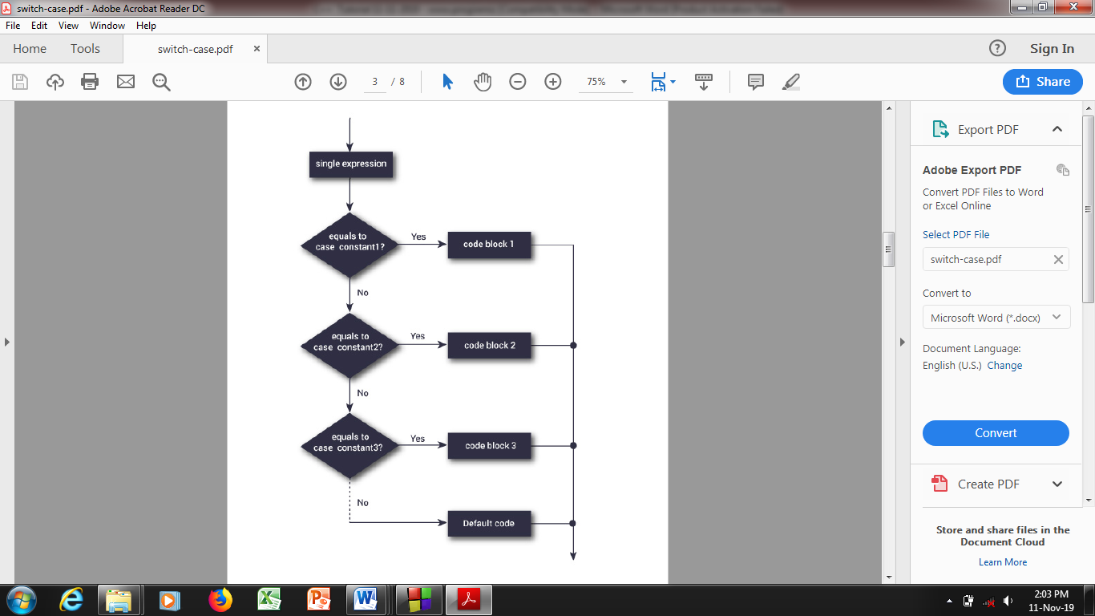
​{
case constant1:
// code to execute if n is equal to constant1;
break;

case constant2:
// code to execute if n is equal to constant2;
break;
.
.
.
default:
// code to be executed if n doesn't match any constant
}

When a case constant is found that matches the switch expression, control of the program passes to the block of code associated with that case.
In the above pseudocode, suppose the value of n is equal to constant2. The compiler will execute the block of code associated with the case statement until the end of switch block,
Flowchart of switch Statement
or until the break statement is encountered. The break statement is used to prevent the code running into the next case. The above figure shows how a switch statement works and conditions are checked within the switch case clause.

As illustrated in following code segment. When the value of the expression (day) is matched against a case value (1,2,..) , the statements execute until a break statement is found. A break statement causes an immediate exit from the switch structure. If the value of the expression does not match any of the case values, the statements following the default label execute.

Sample Program 17:
//This program demonstrates switch statement.
import java.util.Scanner; // Needed for the Scanner class
public class WeekDay{
public static void main(String[] args){
int day; // to hold day value

// Create a Scanner object for keyboard input.
Scanner tola = new Scanner(System.in);

// Get day.
System.out.print("Enter number 1-7 : ");
day = tola.nextInt();

// Determine the corresponding week's day
switch (day)
{
case 1 :
System.out.println("Sunday");
break;

case 2 :
System.out.println("Monday");

break;

case 3 :
System.out.println("Tuesday");

break;

case 4 :
System.out.println("Wednesday");

break;

case 5 :
System.out.println("Thursday");

break;

case 6 :
System.out.println("Friday");

break;

case 7 :
System.out.println("Saturday");

break;

default :
System.out.println("Invalid input");
}
}
}
Output 1:
Enter number 1-7 : 3
Tuesday
Output 2:
Enter number 1-7 : 9
Invalid input

Here is another example of switch statements. The following program asks the user to input choice in y/n and display the output according to value input by user:

Sample Program 18:
//This program demonstrates the switch statement.
import java.util.Scanner; // Needed for the Scanner class
public class SwitchExample{
public static void main(String[] args) {
char choice; // To store the user's choice

// Create a Scanner object to read input.
Scanner key = new Scanner(System.in);

// Ask the user to enter y or n.
System.out.print("Enter Y or N: ");
choice = key.next().charAt(0);

// Determine which character the user entered.
switch (choice)
{
case 'Y' :
case 'y' :
System.out.println("You entered Y.");

break;

case 'N' :
case 'n' :
System.out.println("You entered N.");

break;

default :
System.out.println("Incorrect Input!");
}
}
}

4.5 Conditional Operator
In Java, a ternary operator can be used to replace the if...else statement in certain situations. The ternary operator operates on 3 operands (condition, expression1 and expression2). A ternary operator evaluates the test condition and executes a block of code based on the result of the condition. This ternary operator is ?. Its syntax is:
condition ? expression1 : expression2;
An example of the way that the ? operator is used:
max = number1 > number2 ? number1 : number2;

When Java evaluates this assignment expression, it first looks at the expression to the left of the question mark. If number1 is greater than number2, then the expression between the question mark and the colon is evaluated and used as the value of the entire ? expression. If number2 is greater, then the expression after the colon is evaluated and used for the value of the entire ? expression. The result produced by the ? operator is then assigned to max.

Sample Program 19:
// Java program to find largest among two numbers using ternary operator
import java.util.Scanner;
public class Ternary {
public static void main(String[] args){
// variable declaration
int n1 = 15, n2 = 10, max;

System.out.println("First num: " + n1);
System.out.println("Second num: " + n2);

// Largest among n1 and n2
max = (n1 > n2) ? n1 : n2;

// Print the largest number
System.out.println("Maximum is = " + max);
}
}

Sample Program 20:
After an examination, the marks obtained by a student in 3 different subjects are input by the user. Write a program to calculate the average of subjects. The student gets a grade as per the following rules:
Average | Grade
90-100 | A
80-89 | B
70-79 | C
60-69 | D
0-59 | F

//Program to compute grade
import java.util.Scanner;
public class GradeComputation2{
public static void main(String[] args){
int marks1, marks2, marks3; // To hold marks in three subjects
double average; // To hold average Marks
char grade; // To hold grade

// Create a Scanner object to read input.
Scanner mat = new Scanner(System.in);

// Get value from the user.
System.out.print("Enter marks of subject 1: ");
marks1 = mat.nextInt();

System.out.print("Enter marks of subject 2: ");
marks2 = mat.nextInt();

System.out.print("Enter marks of subject 3: ");
marks3 = mat.nextInt();

// Calculate average marks.
average = (marks1 + marks2 + marks3) / 3.0;

if (average >= 90)
{
grade = 'A';
}
else if (average >= 80)
{
grade = 'B';
}
else if (average >= 70)
{
grade = 'C';
}
else if (average >= 60)
{
grade = 'D';
}
else
{
grade = 'F';
}

// Display grade.
System.out.println("Grade is: " + grade);
}
}

Exercise 4: Write a program that asks the user to enter a number and displays whether entered number is an odd number or even number.
Exercise 5: Write a program that asks the user to enter a number and displays the absolute value of that number.
Exercise 6: Revenue can be calculated as the selling price of the product times the quantity sold, i.e. revenue = price × quantity. Write a program that asks the user to enter product price and quantity and then calculate the revenue. If the revenue is more than #50,000 a discount is 10% offered. Program should display the discount and net revenue.
Exercise 7: Using swing facility, write a program that asks the user to enter a numbers in three variables and then displays the largest number.
Exercise 8: Write a program that prompts the user to input a number. The program should then output the number and a message saying whether the number is positive, negative, or zero.
Exercise 9: A triangle is valid if the sum of all the three angles is equal to 180 degrees. Write a program that asks the user to enter three integers as angles and check whether a triangle is valid or not.
Exercise 10: Any year is input by the user. Write a program to determine whether the year is a leap year or not. Leap Years are any year that can be evenly divided by 4. A year that is evenly divisible by 100 is a leap year only if it is also evenly divisible by 400.
Exercise 11: Write a program to calculate the monthly telephone bills as per the following rule:
Minimum #200 for up to 100 calls.
Plus 0.60k per call for next 50 calls.
Plus 0.50k per call for next 50 calls.
Plus 0.40k per call for any call beyond 200 calls.
Exercise 12: Write a program that prompts the user to enter grade and display the corresponding meaning of grade as per the following table:
Grade | Meaning
A | Excellent
B | Good
C | Average
D | Deficient
F | Failing

MODULE 5: LOOPS - REPETITION STRUCTURE IN JAVA

5.1 The Increment and Decrement Operators
Incrementing and decrementing are such common operations that Java provides special operators for them. The ++ operator adds one to the current value of an int or char. - - subtracts one. Neither operator works on doubles, Booleans or Strings.

Sample Program 21:
//This program demonstrates the ++ and -- operators
public class IncrementDecrement{
public static void main(String[] args){
int number = 50;

// Display the value in number.
System.out.println("Number is " + number);

// Increment number.
number++;

// Display the value in number.
System.out.println("Now, number is " + number);

// Decrement number.
number--;

// Display the value in number.
System.out.println("Now, number is " + number);
}
}
Output:
Number is 50
Now, number is 51
Now, number is 50

Increment and decrement operators each have two forms: pre and post. In above example we have used the post form of increment and decrement operator.

The example of the increment operator is:
Pre-increment:
++number;
Post-increment:
number++

The example of the decrement operator is:
Pre-decrement:
--number;
Post-decrement:
number--
Both the pre- and post-increment operators increment the value of the variable by 1. Similarly, the pre and post decrement operators decrement the value of the variable by 1. The difference becomes apparent when the variable using these operators is employed in an expression.
Suppose a and b are int variables and:
a = 5;
b = 10 + (++a);

To execute the second statement, first the value of a is incremented to 6. Then, 10 is added to 6 to get 16, which is then assigned to b. Therefore, after the second statement executes, a is 6 and b is 16. On the other hand, after the execution of:

a = 5;
b = 10 + (a++);

First the value of a is added to 10, which is then assigned to b, after execution of statement
a is incremented. Therefore, after the second statement executes, a is 6 and b is 15.

5.2 The for loop
The C++ for Loop Syntax:
for(initializationStatement; testExpression; updateStatement) {

// codes
}
where, only testExpression is mandatory.
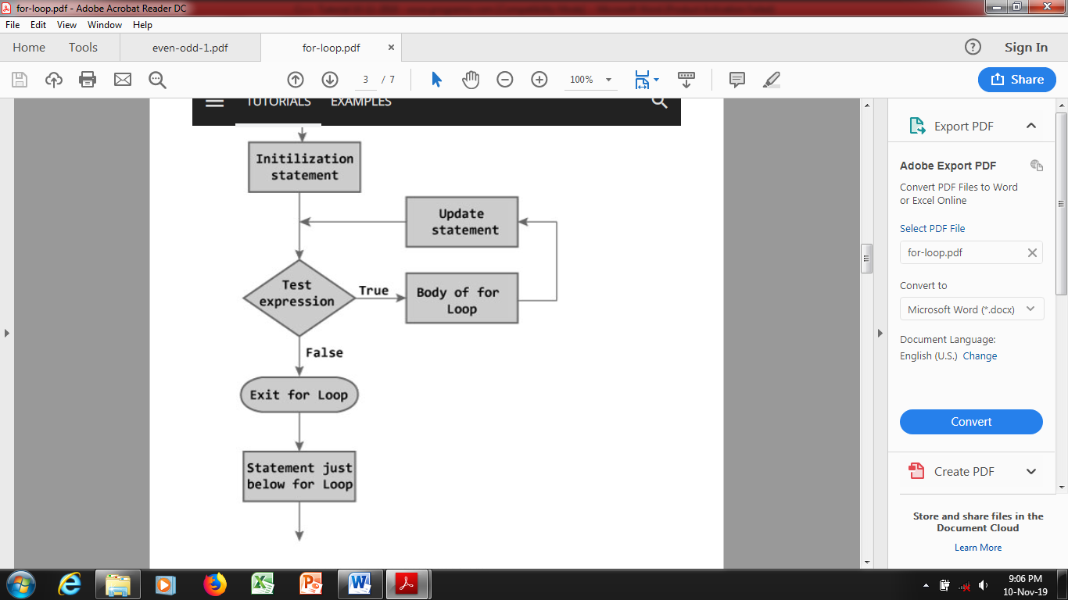
Flowchart of ‘for loop’
How for loop works:
- The for loop statement starts with the keyword for, followed by a pair of parentheses enclosing initial-action, loop-continuation-condition, and action-after-each-iteration, and the loop body, enclosed inside braces.
- initial-action, loop-continuation-condition, and action-after-each-iteration are separated by semicolons;
- A for loop generally uses a variable to control how many times the loop body is executed and when the loop terminates.
- This variable is referred to as a control variable. The initial-action often initializes a control variable, the action-after-each-iteration usually increments or decrements the control

variable, and the loop-continuation-condition tests whether the control variable has reached a termination value.

The syntax looks like this:
for (int count = 0; count <= 10; count++)
{
System.out.println(count);
}

Sample Program 22:
//Program to calculate the sum of first 10 natural number.
public class SumNumbers{
public static void main(String[] args) {
int sum = 0;
for(int i=1; i<=10; i++)
{
sum += i;
}
System.out.println("Sum: " + sum);
}
}

5.3 The While loop (pre-test loop)
The syntax of a while loop is:
while (testExpression)
{
// codes
}
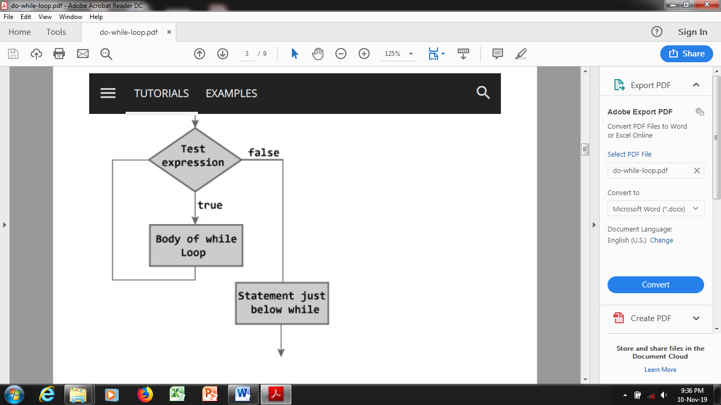
where, testExpression is checked on each entry of the while loop.
How while loop works
- The while loop evaluates the test expression.
- If the test expression is true, codes inside the body of while loop is evaluated.
- Then, the test expression is evaluated again. This process goes on until the test expression is false.
- When the test expression is false, while loop is terminated.
Flowchart of while Loop

Sample Program 23:
//This program demonstrates the while loop.
public class WhileLoop{
public static void main(String[] args){
int count = 1; // count is initiliazed
while (count <= 10) // count is tested
{
System.out.print(count + " "); //or System.out.print(count + " " + "\n");
System.out.print(" "); //optional
count++; // count is changed
}
}
}
Output:
1 2 3 4 5 6 7 8 9 10

The first statement in the loop prints value of count. The second statement uses the increment operator to add one to number. After it executes, the loop starts over. It tests the boolean expression again. If it is true, the statements in the body of the loop are executed. This cycle repeats until the boolean expression number <= 10 is false. Loop in above example is controlled by a counter, above example is counter controlled loop. Loop in next example is a sentinel controlled loop, a special value (the "sentinel") that is used to say when the loop is done.

Sample Program 24:
//This program demonstrate sentinel controlled while loop.
import java.util.Scanner; // needed for Scanner class
public class AddNumbers{
public static void main(String[] args){
int value; // to hold number
int sum = 0; // initialize the sum

// Create a Scanner object for keyboard input.
Scanner h = new Scanner(System.in);

// Get the first value.
System.out.print("Enter first integer (enter 0 to quit): ");
value = h.nextInt();

while (value != 0)
{
// Add value to sum
sum = sum + value;
// Get the next value from the user
System.out.print("Enter next integer (enter 0 to quit): ");
value = h.nextInt();
}
// Display the total.
System.out.println("Sum of the integers: " + sum);
}
}
Output:
Enter first integer (enter 0 to quit): 12
Enter next integer (enter 0 to quit): 3
Enter next integer (enter 0 to quit): 5
Enter next integer (enter 0 to quit): 0
Sum of the integers: 20

5.4 The do-while loop (post-test loop)
The do...while loop is a variant of the while loop with one important difference. The body of do...while loop is executed once before the test expression is checked.
The syntax of do..while loop is:
do {
// codes;
}
while (testExpression);
How do...while loop works
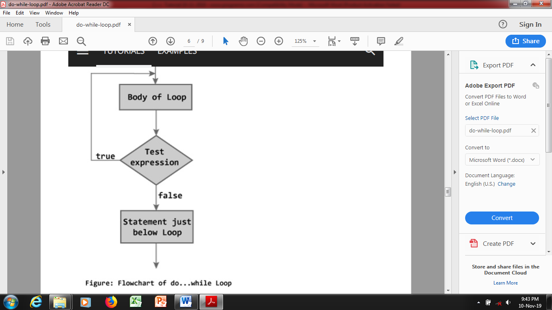
- The codes inside the body of loop are executed at least once. Then, only the test expression is checked.
- If the test expression is true, the body of loop is executed. This process continues until the test expression becomes false.
When the test expression is false, do...while loop is terminated.

Flowchart of do...while Loop

Sample Program 25:
//This program demonstrate do while loop.
import java.util.Scanner; // needed for Scanner Class
public class AddNumbers{
public static void main(String[] args){
int value; // to hold data entered by the user
int sum = 0; // initialize the sum
char choice; // to hold 'y' or 'n'

// Create a Scanner object for keyboard input.
Scanner red = new Scanner(System.in);

do
{
// Get the value from the user.
System.out.print("Enter integer: ");
value = red.nextInt();

// add value to sum
sum = sum + value;

// Get the choice from the user to add more number
System.out.print("Enter Y for yes or N for no: ");
choice = red.next().charAt(0);
}
while ((choice == 'y') || (choice == 'Y'));

//Display the total.
System.out.println("Sum of the integers: " + sum);
}
}
Output:
Enter integer: 6
Enter Y for yes or N for no: y
Enter integer: 8
Enter Y for yes or N for no: y
Enter integer: 4
Enter Y for yes or N for no: n
Sum of the integers: 18

Exercise 13: Write a program to print a sequence of values in the left column and their logarithms in the right column.
Exercise 14: Write a program to print numbers from 1 to 10.

5.5 Nested loop
A loop can have more than one loop nested in it. A for loop can contain any kind of statement in its body, including another for loop. The inner loop must have a different name for its loop counter variable so that it will not conflict with the outer loop.
Consider the following snippet:
// outer loop
for (int i = 1; i <= 5; ++i) {
// codes
// inner loop
for(int j = 1; j <=2; ++j) {
// codes
}
..
}

Here, we are using a “for loop” inside another for loop. We can use the nested loop to iterate through each day of a week for 3 weeks. In this case, we can create a loop to iterate three times (3 weeks). And, inside the loop, we can create another loop to iterate 7 times (7 days).

Sample Program 26:
public class Main{
public static void main(String[] args) {
int weeks = 3;
int days = 7;
// outer loop prints weeks
for (int i = 1; i <= weeks; ++i) {
System.out.println("Week: " + i);
// inner loop prints days
for (int j = 1; j <= days; ++j) {
System.out.println(" Day: " + j);
}
}
}
}

Output:
Week: 1
Day: 1
Day: 2
Day: 3
..... .. ....
Week: 2
Day: 1
Day: 2
Day: 3
.... .. ....
.... .. ....
In the above example, the outer loop iterates 3 times and prints 3 weeks. And, the inner loop iterates 7 times and prints the 7 days.

We can also create nested loops with while and do...while in a similar way.
Note: It is possible to use one type of loop inside the body of another loop. For example, we can put a ‘for loop’ inside the while loop.

Sample Program 27:
//Java for loop inside the while loop
public class Main {
public static void main(String[] args) {
int weeks = 3;
int days = 7;
int i = 1;
// outer loop
while (i <= weeks) {
System.out.println("Week: " + i);
// inner loop
for (int j = 1; j <= days; ++j) {
System.out.println(" Days: " + j);
}
++i;
}
}
}
Output:
Week: 1
Day: 1
Day: 2
Day: 3
.... .. ....
Week: 2
Day: 1
Day: 2
Day: 3
.... .. ....
.... .. ....

Here you can see that the output of both Example 1 and Example 2 is the same.

5.6 The break and continue Statement
Using break statement: When a break statement is encountered inside a loop, the loop is terminated and program control resumes at the next statement following the loop. Here is a simple example:

Sample Program 29:
//This program demonstrates break to exit a loop.
public class BreakExample{
public static void main(String[] args) {
for (int i = 1; i <= 10; i++)
{
if (i == 5)
{
break; // terminate loop if i is 5
}

System.out.print(i + " ");
}

System.out.println("Loop is over.");
}
}
Output:
1 2 3 4 Loop is over.

Using continue statement: When a continue statement is encountered inside the body of a loop, remaining statements are skipped and loop proceeds with the next iteration. Here is a simple example.

Sample Program 30:
//This program demonstrates continue to skip remaining statements of iteration.
public class ContinueExample{
public static void main(String[] args) {
for (int i = 1; i <= 10; i++)
{
if (i % 2 == 0)
{
continue; // skip next statement if i is even
}

System.out.println(i + " ");
}
}
}
Output:
1 3 5 7 9

Exercise 15: Two numbers are entered through the keyboard. Write a program to find the value of one number raised to the power of another. (Do not use Java built-in method).
Exercise 16: Write a program that reads a set of integers, and then prints the sum of the even and odd integers.
Exercise 17: Write a program that prompts the user to input a positive integer. It should then output a message indicating whether the number is a prime number.
Exercise 18: Write a do-while loop that asks the user to enter two numbers. The numbers should be added and the sum displayed. The loop should ask the user whether he or she wishes to perform the operation again. If so, the loop should repeat; otherwise it should terminate.

MODULE 6: JAVA ARRAYS

6.1 Introduction
An array is a collection of similar types of data. For example, if we want to store the names of 100 people then we can create an array of the string type that can store 100 names.
String[] array = new String[100];
Here, the above array cannot store more than 100 names. The number of values in a Java array is always fixed.
Array can either be one-dimensional or multi-dimensional array.

6.2 One-dimensional Array in Java
a. Array Declaration in Java
In Java, here is how we can declare an array.
dataType[] arrayName;
- dataType - it can be primitive data types like int, char, double, byte, etc. or Java objects
- arrayName - it is an identifier

For example, double[] data;

Here, data is an array that can hold values of type double. To define the number of elements that an array can hold, we have to allocate memory for the array in Java. For example,
// declare an array
double[] data;
// allocate memory
data = new Double[10];
Here, the array can store 10 elements and the size or length of the array is 10.

b. Array Declaration and Memory Allocation
In Java, we can declare and allocate memory of an array in one single statement. For example,
double[] data = new double[10];

c. Initializing Arrays in Java
In Java, we can initialize arrays during declaration. For example,
//declare and initialize and array
int[] age = {12, 4, 5, 2, 5};
Here, we have created an array named age and initialized it with the values inside the curly brackets. Note that we have not provided the size of the array. In this case, the Java compiler automatically specifies the size by counting the number of elements in the array (i.e. 5).

d. Array Index
In the Java array, each memory location is associated with a number. The number is known as an array index. We can also initialize arrays in Java, using the index number. For example,
// declare an array
int[] age = new int[5];
// initialize array
age[0] = 12;
age[1] = 4;
age[2] = 5;
..

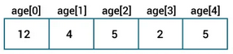

Note: Array indices always start from 0. That is, the first element of an array is at index 0.
If the size of an array is n, then the last element of the array will be at index n-1.

e. Accessing Elements of an Array in Java
We can access the element of an array using the index number. The syntax is:
// access array elements
array[index]
Let's see an example of accessing array elements using index numbers.

Sample Program 31
//Program to access array elements
class Main {
public static void main(String[] args) {
// create an array
int[] age = {12, 4, 5, 2, 5};

// access each array elements
System.out.println("Accessing Elements of Array:");
System.out.println("First Element: " + age[0]);
System.out.println("Second Element: " + age[1]);
System.out.println("Third Element: " + age[2]);
System.out.println("Fourth Element: " + age[3]);
System.out.println("Fifth Element: " + age[4]);
}
}
Output:
Accessing Elements of Array:
First Element: 12
Second Element: 4
Third Element: 5
Fourth Element: 2
Fifth Element: 5
In the above example, notice that we are using the index number to access each element of the array. We can use loops to access all the elements of the array at once.

f. Looping Through Array Elements
In Java, we can also loop through each element of the array. For example,

Sample Program 32
//Using for-loop to access elements of an array
class Main {
public static void main(String[] args) {

// create an array
int[] age = {12, 4, 5};

// loop through the array
// using for loop
System.out.println("Using for Loop:");
for(int i = 0; i < age.length; i++) {
System.out.println(age[i]);
}
}
}
Output:
Using for Loop:
12
4
5

In the above example, we are using the for Loop in Java to iterate through each element of the array. Notice the expression inside the loop,
age.length

Here, we are using the length property of the array to get the size of the array. We can also use the for-each loop to iterate through the elements of an array. For example,

Sample Program 33
//Program to use for-each loop to access elements of an array
class Main {
public static void main(String[] args) {

// create an array
int[] age = {12, 4, 5};

// loop through the array
// using for loop
System.out.println("Using for-each Loop:");
for(int a : age) {
System.out.println(a);
}
}
}
Output:
Using for-each Loop:
12
4
5

Sample Program 34
//Program to compute Sum and Average of Array Elements
class Main {
public static void main(String[] args) {

int[] numbers = {2, -9, 0, 5, 12, -25, 22, 9, 8, 12};
int sum = 0;
Double average;

// access all elements using for each loop
// add each element in sum
for (int number: numbers) {
sum += number;
}

// get the total number of elements
int arrayLength = numbers.length;

// calculate the average
// convert the average from int to double
average = ((double)sum / (double)arrayLength);

System.out.println("Sum = " + sum);
System.out.println("Average = " + average);
}
}
Output:
Sum = 36
Average = 3.6

In the above example, we have created an array of named numbers. We have used the for...each loop to access each element of the array. Inside the loop, we are calculating the sum of each element. Notice the line,
int arrayLength = number.length;

Here, we are using the length attribute of the array to calculate the size of the array. We then calculate the average using:
average = ((double)sum / (double)arrayLength);

As you can see, we are converting the int value into double. This is called type casting in Java as mentioned in the earlier module.

g. Specifying Array Size during Program Execution
During program execution, you can first prompt the user to specify the size of the array and then instantiate the object. Look at the following statements:
int size;
System.out.print("Enter the size of the array: ");
size = console.nextInt();
//number of elements in array is the value of the variable size
int[] list = new int[size];

h. Finding largest value in array
Sample Program 35:
//This program find the largest value in an array
public class LargestElement{
public static void main(String[] args){
final int SIZE = 10; // Size of the array

int[] list = new int[SIZE]; // Create an array.
// Fill array with random values
for (int i = 0; i < list.length; i++)
{
list[i] = (int) (Math.random() * 100);
}

int max = 0; // hold index number of largest number

// Finding largest value.
for (int i = 0; i < list.length; i++)
{
if (list[i] > list[max])
{
max = i;
}
}
// Show all elements of array
System.out.print("Elements are : ");

for (int i = 0; i < list.length; i++)
{
System.out.print(list[i] + " ");
}
System.out.println();

// Show largest value of array
System.out.println("Largest value is " + list[max]);
}
}
Output:
Elements are : 27 8 70 5 47 36 86 89 4 40
Largest value is 89
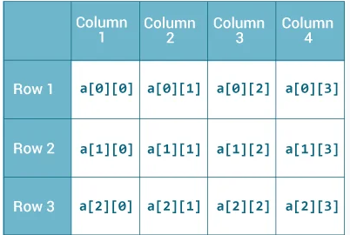

6.3 Java Two Dimensional Arrays
A multidimensional array is an array of arrays. Each element of a multidimensional array is an array itself. For example,

int[][] a = new int[3][4];

Here, we have created a multidimensional array named a. It is a 2-dimensional array, that can hold a maximum of 12 elements.
Remember, Java uses zero-based indexing, that is, indexing of arrays in Java starts with 0 and not 1. Let's take another example of the multidimensional array. This time, we will be creating a 3-dimensional array. For example,
String[][][] data = new String[3][4][2];
Here, data is a 3d array that can hold a maximum of 24 (3*4*2) elements of type String.

- Initializing a 2d array in Java
Here is how we can initialize a 2-dimensional array in Java.
int[][] a = {
{1, 2, 3},
{4, 5, 6, 9},
{7},
};

As we can see, each element of the multidimensional array is an array itself. And also, unlike C/C++, each row of the multidimensional array in Java can be of different lengths.
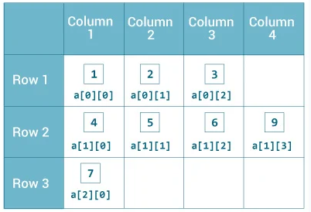

Sample Program 36
//Program to demonstrate a 2-dimensional Array
class MultidimensionalArray {
public static void main(String[] args) {

// create a 2d array
int[][] a = {
{1, 2, 3},
{4, 5, 6, 9},
{7},
};

// calculate the length of each row
System.out.println("Length of row 1: " + a[0].length);
System.out.println("Length of row 2: " + a[1].length);
System.out.println("Length of row 3: " + a[2].length);
}
}
Output:
Length of row 1: 3
Length of row 2: 4
Length of row 3: 1

In the above example, we are creating a multidimensional array named a. Since each component of a multidimensional array is also an array (a[0], a[1] and a[2] are also arrays).
Here, we are using the length attribute to calculate the length of each row.

Sample Program 37
//Program to print all elements of 2d array using loop
class MultidimensionalArray {
public static void main(String[] args) {

int[][] a = {
{1, -2, 3},
{-4, -5, 6, 9},
{7},
};

for (int i = 0; i < a.length; ++i) {
for(int j = 0; j < a[i].length; ++j) {
System.out.println(a[i][j]);
}
}
}
}
Output:
1
-2
3
-4
-5
6
9
7
We can also use the for...each loop to access elements of the multidimensional array.

Sample Program 38
//Using for-each loop in array
class MultidimensionalArray {
public static void main(String[] args) {

// create a 2d array
int[][] a = {
{1, -2, 3},
{-4, -5, 6, 9},
{7},
};

// first for...each loop access the individual array
// inside the 2d array
for (int[] innerArray: a) {
// second for...each loop access each element inside the row
for(int data: innerArray) {
System.out.println(data);
}
}
}
}

In the above example, we are have created a 2d array named a. We then used for loop and for...each loop to access each element of the array.

Initializing a 3d array in Java
Let's see how we can use a 3d array in Java. We can initialize a 3d array similar to the 2d array. For example,
// test is a 3d array
int[][][] test = {
{
{1, -2, 3},
{2, 3, 4}
},
{
{-4, -5, 6, 9},
{1},
{2, 3}
}
};

Basically, a 3d array is like an array of 2d arrays. The rows of a 3d array can also vary in length just like in a 2d array.

Sample Program 39
//3-dimensional Array program
class ThreeArray {
public static void main(String[] args) {

// create a 3d array
int[][][] test = {
{
{1, -2, 3},
{2, 3, 4}
},
{
{-4, -5, 6, 9},
{1},
{2, 3}
}
};

// for..each loop to iterate through elements of 3d array
for (int[][] array2D: test) {
for (int[] array1D: array2D) {
for(int item: array1D) {
System.out.println(item);
}
}
}
}
}
Output:
1
-2
3
2
3
4
-4
-5
6
9
1
2
3

Two-dimensional array is a collection of a fixed number of elements of same data type arranged in rows and columns. Following statement create an array of integers organised in 3 rows and 5 columns:
int[][] numbers = new int[3][5];

Accessing element in a two-dimensional array
To access one of the elements in a two-dimensional array, you must use both subscripts. For example, the following statement stores the number 20 in numbers[1][2]:
numbers[1][2] = 20;

Initializing a Two Dimensional Array
When initializing a two-dimensional array, you enclose each row's initialization list in its own set of braces. Here is an example:
int[][] values { {10, 20, 30}, {40, 50, 60}, {70, 80, 90} };
A pair of nested loops can be used to display all the elements of a two-dimensional array, Here is an example:

Sample Program 40:
//Program to display all the elements of a 2-dimensional array
public class TwoDimArray{
public static void main(String[] args) {
// Array of size 4x3 to hold integers.
int[][] values =
{
{ 10, 20, 30 }, { 40, 50, 60 }, { 70, 80, 90 },
{ 11, 21, 31 }
};

// Nested loops to print the array in tabular form.
for (int row = 0; row < 4; row++)
{
for (int col = 0; col < 3; col++)
{
System.out.print(values[row][col] + " ");
}

System.out.println(); // Print new line.
}
}
}

Output:
10 20 30
40 50 60
70 80 90
11 21 31

Length field in two-dimensional array
A two-dimensional array is an array of one dimensional arrays. Figure shows another way of thinking of the numbers array as an array of arrays. Each row of two-dimensional array has a length field that holds the number of columns. A better approach is to use the array's length fields for the upper limit of the subscripts in the loop test expressions.

Here are the modified loops:
// Nested loops to print the array in tabular form
for (int row = 0; row < values.length; row++)
{
for (int col = 0; col < values[row].length; col++)
{
System.out.print(values[row][col] + " ");
}

System.out.println(); // Print new line.
}

6.4 Variable length Argument Lists
Variable-length argument lists, makes it possible to write a method that accepts any number of arguments when it is called. For example, suppose we need to write a method named sum that can accept any number of int values and then return the sum of those values. We write the method as shown here:
public static int sum(int ... list)
{
//write code here
}
int ... list

This statement declares list to be a variable length formal parameter. In fact, list is an array wherein each element is of type int, and the number of elements in list depends on the number of arguments passed.

Sample Program 41:
//This Program demonstrates variable length arguments.
public class VarArgs{
public static void main(String[] args){
System.out.println("The sum of 5 and 10 is " + sum(5, 10));
System.out.println("The sum of 23, 78, and 56 is "
+ sum(23, 78, 56));
System.out.println("The sum when no parameter is passed is "
+ sum());

int[] numbers = { 23, 45, 89, 34, 92, 36, 90 };

System.out.println("The sum of array is " + sum(numbers));
}
// The sum method takes variable number of arguments.
public static int sum(int... list)
{
int total = 0;

// add all the values in list array
for (int i = 0; i < list.length; i++)
{
total += list[i];
}

return total;
}
}
Output:
The sum of 5 and 10 is 15
The sum of 23, 78, and 56 is 157
The sum when no parameter is passed is 0
The sum of array is 409

6.5 The ArrayList class
In addition to arrays, Java provides the class ArrayList to implement a list. Unlike an array, the size of a ArrayList object can grow and shrink during program execution. Therefore, you need not be concerned about the number of data elements. The elements of a ArrayList are references to Object. Using a ArrayList is slightly slower than using an array.

Sample Program 42:
//This program demonstrates an ArrayList and its methods
import java.util.ArrayList; // Needed for ArrayList class
public class ArrayListExample{
public static void main(String[] args){
// Create an array list.
ArrayList<String> list = new ArrayList<>();

// Display the size of the array list.
System.out.println("Initial size of list: " + list.size());

// Add elements to the array list.
list.add("Sunday");
list.add("Tuesday");
list.add("Wednesday");
list.add("Thursday");
list.add("Friday");
list.add("Saturday");
// Now insert an item at index 1.
list.add(1, "Monday");

// Display the size of the array list.
System.out.println("Size of list after additions: " + list.size());

// Display the array list.
System.out.println("Contents of list: " + list);

// Remove elements from the array list.
list.remove("Saturday");

// Display the array list.
System.out.println("Contents of list: " + list);

// Now remove the item at index 2.
list.remove(2);
// Display the array list.
System.out.println("Contents of list: " + list);
}
}
Output:
Initial size of list: 0
Size of list after additions: 7
Contents of list: [Sunday, Monday, Tuesday, Wednesday, Thursday, Friday, Saturday]
Contents of list: [Sunday, Monday, Tuesday, Wednesday, Thursday, Friday]
Contents of list: [Sunday, Monday, Wednesday, Thursday, Friday]

ArrayList Objects and the foreach Loop
A foreach loop can be used to process the elements of a ArrayList object one at a time. For example, suppose list is an object of ArrayList class of String objects, The code for foreach loop will look like this:
for (String str : list)
{
//write code here
}

Sample Program 43:
//This program demonstrates foreach loop.
import java.util.ArrayList; // Needed for ArrayList class
public class ForEachExample{
public static void main(String[] args) {
// Create an ArrayList.
ArrayList<String> list = new ArrayList<>();

// Add some values to the ArrayList.
list.add("One");
list.add("Two");
list.add("Three");

for (String str : list)
{
System.out.println(str);
}
}
}
Output:
One
Two
Three

Exercise 19: Write Java statements that do the following:
a) Declare an array numArray of 15 elements of type int.
b) Output the value of the tenth element of the array alpha.
c) Set the value of the fifth element of the array alpha to 35.
d) Set the value of the ninth element of the array alpha to the sum of the sixth and thirteenth elements of the array alpha.
Exercise 20: Write a program that creates an array of 10 elements size. Your program should prompt the user to input numbers in array and then display the sum of all array elements.
Exercise 21: Write a Java program to find the largest and smallest element of an array.
Exercise 22: Write a user-defined method in Java to display the multiplication of row element of two-dimensional array A[4][6] containing integer.

MODULE 7: METHODS in JAVA

7.1 Introduction to Methods
A method in Java is a block of statements that has a name and can be executed by calling it from some other place in your program. Methods are used to divide complicated programs into manageable pieces. Using methods has several advantages:
- Different people can work on different methods simultaneously.
- If a method is needed in more than one place in a program, or in different programs, you can write it once and use it many times.
- Using methods greatly enhances the program’s readability because it reduces the complexity of the method main.
There are both predefined methods, methods that are already written and provided by Java, and user-defined methods, methods that you create. Earlier, we have discussed how to use predefined methods. Because Java does not provide every method that you will ever need, you must learn to write your own methods. User-defined methods in Java are classified into two categories:
- Void methods - methods that do not have a return data type. These methods do not use a return statement to return a value.
- Value-returning methods - methods that have a return data type. These methods return a value of a specific data type using the return statement.

7.2 void Method
Look at the following program that demonstrates how a method is defined and called. In this program, we have defined a method displayLine that displays a line. Execution of program start from main and when it encounters statement displayLine() control passes to method and after execution of the code of method control comes back to next statement of main method.

Sample Program 44:
//This program defines and calls a method.
public class MethodExample{
public static void main(String[] args) {
System.out.println("Advantage of methods.");
displayLine();
System.out.println("Write once use many times");
displayLine();
}
//The displayLine method displays a line.
public static void displayLine()
{
for (int i = 1; i <= 40; i++)
{
System.out.print("_");
}
System.out.println(" ");
}
}
Output:
Advantage of methods.
________________________________________
Write once use many times
________________________________________

Method definition
Method definition has two parts, header and body. Following figure explain each of these parts.
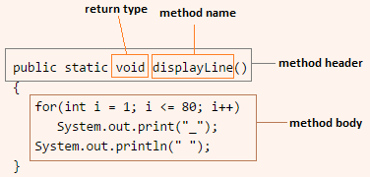

Calling a Method
To call a method, simply type the name of the method followed by a set of parentheses. As we used in above example.
displayLine();

7.3 Passing Arguments to a Method
Values that are sent into a method are called arguments. In the examples of previous module, we defined a method displayLine that display a Line of 40 characters. To call this method we write the statement displayLine();. Now we will modify our displayLine method so that it can can accept arguments. Look at the following example :

Sample Program 45:
//This program demonstrate passing argument to a method.
public class PassingArgument{
public static void main(String[] args){
int x = 30;
System.out.println("Display line of 50 characters");
displayLine(50);
System.out.println("Display line of 30 characters");
displayLine(x);
}

//The displayLine method accept an argument.
public static void displayLine(int n)
{
for (int i = 1; i <= n; i++)
{
System.out.print("_");
}
System.out.println(" ");
}
}
Output:
Display line of 50 characters
__________________________________________________
Display line of 30 characters
______________________________

7.4 Local Variables
Variables declared within a method, become local to the method. Local variables have local scope: They can only be accessed within the function. Local variables are created when a method starts, and deleted when the method is completed.

Sample Program 46:
//This program demonstrate local variable of a method.
import java.util.Scanner; // Needed for the Scanner class
public class LocalVariable{
public static void main(String[] args) {
// Create a Scanner object for keyboard input.
Scanner console = new Scanner(System.in);
int number1, number2; //Hold numbers

//Get number from users
System.out.print("Enter first integer : ");
number1 = console.nextInt();
System.out.print("Enter second integer : ");
number2 = console.nextInt();

//Call method to display sum
sum(number1, number2);
}
//The sum method accept two arguments.
public static void sum(int num1, int num2)
{
int total; // local variable stores intermediate results.
total = num1 + num2;
System.out.println("Total : " + total);
}
}
Output:
Enter first integer : 34
Enter second integer : 31
Total : 65
Exercise 23: Write a program with a method named getTotal that accepts two integers as an argument and return its sum. Call this method from main( ) and print the results.
Exercise 24: Write a method named isPrime, which takes an integer as an argument and returns true if the argument is a prime number, or false otherwise. Also write main method that displays prime numbers between 1 to 500.

MODULE 8: INTRODUCTION TO JAVA CLASSES

8.1 Object and Classes
Until now, we have not really been doing much with objects. The programs so far could just have been written in the languages like C or Pascal. The following will discuss objects and classes, and how an object-oriented language like Java is different from a procedural language like C.

Objects
Many programs are written to model problems of the real world. It is convenient to have "software objects" that are similar to "real world objects." This makes the program and its computation easier to think about. A software object can store data and perform operations. The data stored in an object are commonly called fields and the operations that an object can perform are called methods.

Class
To create a object in memory, you should have a class. A programmer may define a class using Java, or may use predefined classes that come in class libraries such as the JDK. A class contains fields and methods that define the behaviour of the object. You can think of a class as a "blueprint" that can be used to create a particular type of object. In object-oriented programming, programmers use a programming language (such as Java) to describe the program as various objects. When the program is run, the objects are created, and they start "doing things" by running their methods.

8.2 Designing a class
For example, suppose that you want to design the class Rectangle that implements the basic properties of a Rectangle. Now every Rectangle has a width and height, which can be a floating-point value. Therefore, when you created an object of the class Rectangle, then you must store the length and width of the Rectangle into that object. Next, the two basic operations that are performed on a Rectangle are to find the area and perimeter of the Rectangle. Thus, the class Rectangle must provide these two operations. This class needs to provide a few other operations to effectively use this class in a program. In skeleton form, the syntax of the class Rectangle looks as follows:
public class Rectangle{
private double length;
private double width;

public double getArea()
{
// code to determine the area of the Rectangle
}

public double getPerimeter()
{
// code to determine the perimeter of the Rectangle
}

// Additional methods as needed ...
}

In the definition of the class Rectangle, the variable length and width is declared with the keyword private and the methods area and perimeter are declared with the keyword public. When a member of a class is declared private. It can be used only by the methods of that class. The public access modifier permits a member to be accessed by code outside the class.

Variable Declaration and Object Instantiation
Once a class is defined, you can declare reference variables of that class type. For example, the following statement declare rectangle1 to be reference variables of type Rectangle.
Rectangle rectangle1;

To store the length and width, we need to create a Rectangle object, which is accomplished by using the operator new :
rectangle1 = new Rectangle();

You can combine variable declaration and object instantiation in one statement
Rectangle rectangle 2 = new Rectangle();
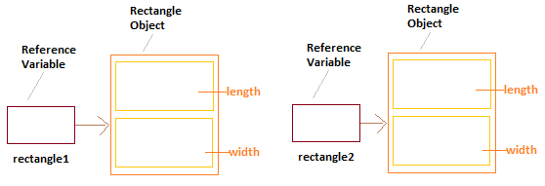

Accessing Class Members
Once an object of a class is created, the object can access the members of the class using dot (.) operator:
rectangle1.set(4.1,6.3)
(RectangleDemo. Java)

Sample Program 47:
//This program test the Rectangle class methods.
public class RectangleExample{
public static void main(String[] args){
// Create a Rectangle object
Rectangle rectangle1 = new Rectangle();

// Accessing class members
rectangle1.set(4.2, 6.2);
System.out.println("Area of Rectangle is "
+ rectangle1.getArea());
System.out.println("Perimeter of Rectangle is "
+ rectangle1.getPerimeter());
}
}
Output:
Area of Rectangle is 26.04
Perimeter of Rectangle is 20.8

8.3 Constructors
A constructor is a member method that automatically initializes an object immediately upon creation. It has the same name as the class with no return type. Let’s defining a simple constructor of Recangle class as shown here:

public Rectangle()
{
length = 0.0;
width = 0.0;
}

When we write following statment to create object constructor automatically invoked and Rectangle object automatically intiliaze with value 0;
Rectangle rectangle1 = new Rectangle();

A constructor can have parameters, this version of constructor is called parameterized constructor. Following code segment define a parameterized constructor.
public Rectangle(double l, double w)
{
length = l;
width = w;
}
Paramterized constructor intializes object with given set of values when object is created, look at following statement :
Rectangle rectangle2 = new Rectangle(3.5, 4.2);

A class can have multiple constructors, compiler differentiate on the basis of parameter passed. This is called overloading of constructor.

8.4 Overloading methods
In Java it is possible to define two or more methods having same name within the same class, as long as their parameter declarations are different. When this is the case, the methods are said to be overloaded, and the process is referred to as method overloading. Overloaded methods must differ in the type and/or number of their parameters. When Java encounters a call to an overloaded method, the method whose arguments match, is called.

8.5 Unified Modelling Language Class Diagrams
A class and its members can be described graphically using Unified Modelling Language (UML) notation.

Layout of a UML diagram for a class
- The top box in the UML diagram contains the name of the class.
- The middle box contains the data members and their data types.
- The last box contains the method names, parameter list, and return types.
- To indicate the data type of a field, place a colon followed by the name of the data type after the name of the field.
- To indicate return type of method place a colon followed by the method name.
- Parameters and their data types inside a method's parentheses.
- The + (plus) sign in front of a member indicates that it is a public member.
- The – (minus) sign indicates that it is a private member.
- The # symbol before a member name indicates that it is a protected member.
In the earlier module, we designed a Rectangle class. Following class diagram represent this.

Rectangle
- length : double
- width : double
+ Rectangle()
+ Rectangle(double, double)
+ set(double, double) : void
+ getArea() : double

References

P. J. Deitel & H. M. Deitel – Java: How to Program, Seventh Edition, Prentice Hall.

Cay S. Horstmann – Core Java Volume I – Fundamentals (Core Series), 11th Edition, Prentice Hall.

Joshua Bloch – Effective Java, 3rd Edition, Addison Wesley.

Herbert Schildt – Java: A Beginner’s Guide, 8th Edition, Mc-Graw-Hill.

www.programiz.com/java-programming

www.studytonight.com/java/

APPENDIX - JAVA Math Methods with Output Functions
Math.abs(): The function returns the absolute value of the parameter passed to it.
Math.ceil(): The function rounds a floating point value up to the nearest integer value. The rounded value is returned as a double. Here is a Math.ceil() Java example:
double ceil = Math.ceil(7.343); // ceil = 8.0
Math.floor(): The function rounds a floating point value down to the nearest integer value. The rounded value is returned as a double. Here is a Math.floor() Java example:
double floor = Math.floor(7.343); // floor = 7.0
Math.floorDiv(): The method divides one integer (int or long) by another, and rounds the result down to the nearest integer value. If the result is positive, the effect is the same as using the Java division operator, /, described in the earlier module. If the result is negative, however, the result is not the same. With the / division operator the fractions are simply truncated. For positive numbers this corresponds to rounding down. For negative numbers though, truncating the fractions correspond to rounding up. The floorDiv() method rounds down to the nearest negative integer, instead of the rounding up that would occur with fraction truncation. Example:
double result3 = Math.floorDiv(-100,9);
System.out.println("result3: " + result3);
double result4 = -100 / 9;
System.out.println("result4: " + result4);
The output printed from this Java code is:
result3: -12.0
result4: -11.0
This shows the difference between the / division operator and Math.floorDiv() .
Math.min(): The method returns the smallest of two values passed to it as parameter. Example:
int min = Math.min(10, 20);
After executing this code the min variable will contain the value 10.
Math.max(): The method returns the largest of two values passed to it as parameter. Example:
int max = Math.max(10, 20);
After executing this code the max variable will contain the value 20.
Math.round(): The method rounds a float or double to the nearest integer using normal math round rules (either up or down). Here is a Java Math.round() example:
double roundedDown = Math.round(23.445);
double roundedUp = Math.round(23.545);
After executing these two Java statements, the roundedDown variable will contain the value 23.0 , and the roundedUp variable will contain the value 24.0.
Math.random(): The method returns a random floating point number between 0 and 1. Of course the number is not fully random, but the result of some calculation which is supposed to make it as unpredictable as possible. Here is a Java Math.random() example:
double random = Math.random();
To get a random value between 0 and e.g. 100, multiply the value returned by Math.random() with the maximum number (e.g. 100). Here is an example of how that might look:
double random = Math.random() * 100D;
If you need an integer value, use the round(), floor() or ceil() method.

Exponential and Logarithmic Math Functions
The Java Math class also contains a set of functions intended for exponential and logarithmic calculations. I will cover some of these math functions in the following sections.
Math.exp(): The function returns e (Euler's number) raised to the power of the value provided as parameter. Example:
double exp1 = Math.exp(1);
System.out.println("exp1 = " + exp1);
double exp2 = Math.exp(2);
System.out.println("exp2 = " + exp2);
When this Java math code is executed it will print this output:
exp1 = 2.718281828459045
exp2 = 7.38905609893065
Math.log(): The method provides the logarithm of the given parameter. The base for the logarithm is i (Euler's number). Thus, Math.log() provides the reverse function of Math.exp(). Example:
double log1 = Math.log(1);
System.out.println("log1 = " + log1);
double log10 = Math.log(10);
System.out.println("log10 = " + log10);
The output from this Math.log() example is:
log1 = 0.0
log10 = 2.302585092994046
Math.log10(): The method works like the Math.log() method except is uses 10 as is base for calculating the logarithm instead of e (Euler's Number). Here is a Math.log10() Java example:
double log10_1 = Math.log10(1);
System.out.println("log10_1 = " + log10_1);
double log10_100 = Math.log10(100);
System.out.println("log10_100 = " + log10_100);
The output printed from this Java Math.log10() example would be:
log10_1 = 0.0
log10_100 = 2.0
Math.pow(): The function takes two parameters. The method returns the value of the first parameter raised to the power of the second parameter. Example:
double pow2 = Math.pow(2,2);
System.out.println("pow2 = " + pow2);
double pow8 = Math.pow(2,8);
System.out.println("pow8 = " + pow8);
The output from this Math.pow() example would be:
pow2 = 4.0
pow8 = 256.0
That is, Math.pow() in the examples calculate the values of 2² and 2⁸ which are 4 and 256.
Math.sqrt(): The method calculates the square root of the parameter given to it. Example:
double sqrt4 = Math.sqrt(4);
System.out.println("sqrt4 = " + sqrt(4));
double sqrt9 = Math.sqrt(9);
System.out.println("sqrt9 = " + sqrt9);
The output printed from these Java Math.sqrt() examples would be:
sqrt4 = 2.0
sqrt9 = 3.0

Trigonometric Math Functions
The Java Math class contains a set of trigonometric functions. These functions can calculate values used in trigonometry, like sine, cosine, tangent etc. I will cover the most used trigonometry functions in the following sections. If you are looking for a trigonometric function and you cannot find it here, check the JavaDoc for the Java Math class. The Math class just might have the function you are looking for, even if I have not described it here.
Math.PI: The Math.PI constant is a double with a value that is very close to the value of PI - the mathematical definition of PI. You will often need the Math.PI field when making trigonometric calculations.
Math.sin(): The method calculates the sine value of some angle value in radians. Example:
double sin = Math.sin(Math.PI);
System.out.println("sin = " + sin);
Math.cos(): The method calculates the cosine value of some angle value in radians. Example:
double cos = Math.cos(Math.PI);
System.out.println("cos = " + cos);
Math.tan(): The method calculates the tangent value of some angles value in radians. Example:
double tan = Math.tan(Math.PI);
System.out.println("tan = " + tan);
System.out.println("tanh = " + tanh);
Math.toDegrees(): The method converts an angle in radians to degrees. Example:
double degrees = Math.toDegrees(Math.PI);
System.out.println("degrees = " + degrees);
Math.toRadians(): The method converts an angle in degrees to radians. Example:
double radians = Math.toRadians(180);
System.out.println("radians = " + radians);

Tutorial Questions
- Java Fundamentals
- In the Java programming language, all source code is first written in plain text files ending with the …………….extension.
- What does Java compiler generate?
- What does JVM stands for?
- Write the signature of the main method.
- Which of the following are not valid assignment statements?
a. sum = 9; b. 72 = cost; c. price = 129 d. ans = 'y'
- Which of the following are valid Java identifiers?
myFirstProgram 1stProgram Program1 David'sFirstProgram First Program FIRST_PROGRAM
- This is a named storage location in the computer's memory called?
- Which of the following is not primitive data type? String, double, Boolean, int
- Write Java statements that perform following tasks.
a. Declare int variables a and b.
b. Initialize an int variable x to 10 and a char variable char to 'y'.
c. Declare and initialize a double variable payRate to 12.50.
d. Declare a boolean variable ans and set the value of ans to true.
- Write the output of the following expressions.
a. System.out.println(13 / 4);
b. System.out.println(2 + 12 / 4);
c. System.out.println(21 % 5);
d. System.out.println(3 - 5 % 7);
e. System.out.println(17.0 / 4);
f. System.out.println(8 - 5 * 2.0);
g. System.out.println(14 + 5 % 2 - 3);
- What is the value of each variable after the last statement executes?
int a, b, c;
double x, y;
a = 17;
b = 15;
a = a + b / 4;
c = a % 3 + 4;
x = 17 / 3 + 6.5;
y = a / 4.0 + 15 % 4 - 3.5;
- Suppose x, y, and sum are int variables and z is a double variable. What value is assigned to sum variable after statement executes? Suppose x = 3, y = 5, and z = 14.1.
sum = x + y + (int) z;
- Write equivalent statements using combined assignment for the following, if possible.
x = 2 * x;
x = x + y - 2;
sum = sum + num;
y = y / (x + 5);
- The Welcome.java has some errors. Fix the errors so that the program successfully compiles and runs.
class FixProgram
{
public static void main(String[] args)
{
System.out.println('Hello World!')
}
}

b. General Questions
- Explain what you understand by OOP and state 4 features of OOP.
- Mention any two usage of Java programming language.
- What is the basic requirement of compiling and running Java codes?
- List and describe 6 arithmetic operators in Java with example in each case.
- Write the syntax for conditional operator in Java.
- What is the difference between keywords and identifiers?
- List any four features of Java programming language and explain any one of them.
- What are the two classes of data types in Java?
- What is looping? List three ways looping can be implemented in Java
- Write a “for loop” syntax in Java.
- What is the difference between keywords and identifiers?
- Enumerate 3 decision-making statements in Java. Hence, write the syntax for implementing “if-then-else” statement in Java.
- Explain the term “array” and list any 2 features of array.
- Write a syntax for array declaration in Java.
- Differentiate between “object” and “class” in OOP.
- What do you understand by “inheritance” and “polymorphism”?
- A manufacturing company pays overtime allowance to each of its employees in addition to each employee’s fixed daily pay. Overtime is paid at N280 per hour (excluding fractional part) if the number of hours worked exceeds 8 hours per day regardless of the status of the employee. Write a Java program to calculate the total pay for each employee using Javax swing method.
- If a university in Nigeria uses the following CGPA values to classify the classes of degree: 1st class: 4.50 –5.00; 2nd class upper: 3.50 – 4.49; 2nd class lower: 2.40 - 3.49; Third class: 1.50 – 2.39; Failed: below 1.50. Write a Java program to perform this task using (i) “The student has” string as part of the output and (ii) Javax swing method.
- After conducting examination to a group of students, 56.7% average grade was set as minimum criteria for each student to obtain a “Promoted” remark. Otherwise, the student receives a “Failed” remark. Write a Java program to implement the task using (i) conditional operators (ii) if-else in each case.
- Write a Java program to output multiples of 4 between 1 and 80 inclusive.
- Write a program to compute the customer’s account balance if he deposits amount P, for a period T and rate R based on simple interest. Use Javax swing method for the program.
- Write a Java program to count down all even integers between 1 and 20 inclusive.
- Write a program to display a certain day of the week using both if-then-else and switch case.
- If a triangle has side lengths a, b, c. Write a program that asks the user to enter three sides of triangle. The program should compute and display the area of triangle.
Note: Area = where s = (Note: Use both Scanner class and Swing method).
- Write a program to find the roots of the quadratic equation of the form ax²-bx+c =0 using scanner class. Hence, find the roots of the equation 3x²-12x+10 =0. (Roots are 2.82, 1.18)
- Given sides ‘a’ and ‘c’ and angle B between them in triangle ABC, write a program to find the length of side ‘b’ using Swing method. Furthermore, find the length of side ‘b’ (in cm) if sides ‘a’, ‘c’ and angle B are 8.44cm, 7.92cm and 151.3⁰ respectively.
(Note: b = ) (Answer: b = 15.9cm)
- Write a program to compute both simple and compound interests on principal P, rate R and time T. Hence, find the simple and compound interests if a customer deposits #10,000 in a bank for 3 years at 5.6% annual interest rate.
Note:
For Compound Interest: Amount = [P(1 + R)^{T} – 1] while Interest = Amount – Principal
For Simple Interest: Interest = (PRT)/100 while Amount = Interest + Principal

